A Project Report On

Student Placement Analysis and Prediction

Submitted in partial fulfilment of the requirement for the

award of the degree
MASTER OF COMPUTER APPLICATIONS

Academic Year 2025 – 26
For subject
05MC0207 - Data Analytics and Visualization

Ankit Kumar _92500584110
Ankush Kumar _92500584141

Internal Guide
Dr. Vivek Gondalia



Rajkot-Morbi Road, At & PO: Gauridad, Rajkot 360 003. Gujarat. India.

DECLARATION

I hereby declare that this project work entitled Student Placement Analysis and
Predictions a record done by me.

I also declare that the matter embodied in this project is genuine work done by me and has not been submitted whether to this University or to any other University for the fulfilment of any course of study.

Place: Rajkot
Date: 18th April, 2026

Ankit Kumar_92500584110
Ankush Kumar_92500584141

ACKNOWLEDGEMENT

It is indeed a great pleasure to express my/our thanks and gratitude to all those who helped me. No serious and lasting achievement one can ever achieve without the help of friendly guidance and co-operation of so many people involved in the work.

I am very thankful to my faculty guide Dr. Vivek Gondalia, the person who makes me follow the right steps during project work. I express my deep sense of gratitude to her guidance, suggestions and expertise at every stage. Apart from that her valuable and expertise suggestion during documentation of my report indeed helped me a lot.

Thanks to my friends who have been a source of inspiration and motivation that helped me during my project work. I am also thankful to our Head Dr. Sunil Bajeja and Dean Dr Rizwan Khan for their support as and when required. I would like to extend my gratitude towards all who directly or indirectly supported and helped me to accomplish my project work.

Ankit Kumar_92500584110
Ankush Kumar_92500584141

Table of Contents
Table of Contents 4
1. Abstract 8
2. Introduction 10
2.1 Background and Context 10
2.2 The Role of Data Science in Placement Prediction 10
2.3 Problem Statement 11
2.4 Significance of the Study 11
3. Objectives of the Project 12
3.1 Primary Objectives 12
3.2 Secondary Objectives 12
4. Dataset Description 13
4.1 Overview 13
4.2 Feature Description 13
4.3 Target Variable Analysis 14
5. Data Preprocessing 15
5.1 Overview of the Preprocessing Pipeline 15
5.2 Identifier Removal 15
5.3 Categorical Variable Encoding 15
5.4 Feature Engineering 15
5.5 Feature Scaling 16
6. Exploratory Data Analysis 18
6.1 Overview 18
6.2 Category 1: Placement Overview 18
Graph 1: Placement Status Overview 18
Graph 2: Gender vs. Placement 19
Graph 3: College Tier vs. Placement 21
Graph 4: Placement Rate by Engineering Branch 22
Graph 5: Salary Package Distribution 23
6.3 Category 2: Academic Performance 25
Graph 6: CGPA Distribution by Placement Status 25
Graph 7: CGPA by Branch and Placement (Box Plot) 26
Graph 8: Backlogs Impact and CGPA Violin Plot 27
Graph 9: Attendance vs. Placement 28
Graph 10: Study Hours Density by Placement 30
Graph 11: Academic Score by College Tier and Placement 31
Graph 12: Age vs. CGPA Scatter 32
6.4 Category 3: Skills Analysis 33
Graph 13: Average Skill Scores by Placement Status 33
Graph 14: Composite Skill Score KDE 34
Graph 15: Skill Radar Chart 35
Graph 16: Mock Interview Score Analysis 37
Graph 17: Coding Skill vs. Salary 38
Graph 18: All Skill Score Box Plots 40
6.5 Category 4: Experience Factors 41
Graph 19: Internships Impact on Placement and Salary 41
Graph 20: Projects Impact on Placement 43
Graph 21: Certifications vs. Placement Rate 44
Graph 22: Hackathons vs. Placement 45
Graph 23: Activity Score KDE by Placement 46
Graph 24: Online Presence vs. Placement 47
6.6 Category 5: Behavioural Factors 48
Graph 25: Behavioural Scores by Placement 48
Graph 26: Volunteer Experience vs. Placement Rate 49
Graph 27: Sleep Hours vs. Placement Rate 50
Graph 28: Study Hours Heatmap by Branch and Tier 52
Graph 29: Behavioural Score vs. Salary 53
6.7 Category 6: Correlation Analysis 54
Graph 30: Full Correlation Heatmap 54
Graph 31: Feature Correlation with Placement Outcome 56
Graph 32: Pairplot of Key Features 57
6.8 Category 7: Feature Interactions 58
Graph 33: CGPA vs. Skill by College Tier 58
Graph 34: Activity Score × Mock Interview Density 59
Graph 35: Placement Rate Heatmap — Internships × CGPA 61
Graph 36: Salary by Branch and College Tier 62
Graph 37: Online Presence × Activity Score 63
7. Machine Learning Implementation 65
7.1 Problem Formulation 65
7.2 Feature Selection 65
7.3 Train-Test Split 65
7.4 Class Weight Balancing 65
7.5 Pipeline Architecture 66
7.6 Model 1: Logistic Regression 66
7.7 Model 2: Decision Tree 66
7.8 Model 3: Random Forest 67
7.9 Cross-Validation Results (K=5) 67
8. Model Evaluation 68
8.1 Evaluation Metrics 68
8.2 Results Summary 68
8.3 Confusion Matrix Analysis 68
8.4 ROC Curve Analysis 70
8.5 Model Comparison 71
8.6 Classification Report Analysis 73
8.7 Probability Distribution Analysis 74
9. Feature Importance and Analysis 76
9.1 Random Forest Feature Importance 76
9.2 Interpretation of Feature Ranking 77
9.3 Salary Analysis by Skill Band 78
10. Final Prediction System 80
10.1 Prediction Architecture 80
10.2 Example Prediction 80
11. Real-World Applications 82
11.1 For Educational Institutions and Placement Cells 82
11.2 For Students 82
11.3 For Recruiters 82
12. Limitations 83
13. Future Scope 84
14. Deployment Architecture 85
14.1 Proposed Streamlit Web Application 85
14.2 Application Flow 85
14.3 Technical Stack 85
15. Viva Questions and Answers 86
Q1. Why did you choose a classification model rather than a regression model for this problem? 86
Q2. What is the difference between Precision and Recall? Which is more important in this context? 86
Q3. What is the AUC-ROC curve? Why did you use it? 86
Q4. How did you handle class imbalance? 87
Q5. Why is Random Forest better than a single Decision Tree? 87
Q6. What is the purpose of StandardScaler? When should it NOT be applied? 87
Q7. Explain the K-Fold Cross-Validation procedure and why you used it. 87
Q8. What is Feature Engineering? What composite features did you create and why? 88
Q9. What is overfitting? How did you prevent it? 88
Q10. Why did you drop the student_id and salary_package_lpa columns? 88
Q11. How does the Pipeline prevent data leakage? 89
Q12. What does the Feature Importance plot tell us? Is it different from correlation? 89
Q13. What is the difference between bagging and boosting? 89
Q14. Explain the Confusion Matrix in the context of your project. 89
Q15. What are the advantages and disadvantages of Logistic Regression? 90
Q16. How would you deploy this model in production? 90
Q17. Why is the AUC moderate (~0.56)? Is this acceptable? 90
Q18. What is the GridSearchCV process? How did you apply it? 91
Q19. What is Multicollinearity? Does it affect your models? 91
Q20. How would you improve this model's performance? 91
16. References 93

1. Abstract
Campus placement is one of the most consequential milestones in an engineering student's academic journey. The ability to predict whether a student will be placed — and at what salary — before the actual recruitment season empowers institutions, students, and recruiters to act proactively rather than reactively. This project, titled 'Student Placement Analysis and Prediction,' presents a comprehensive data science solution that transforms raw academic and behavioural data into actionable placement intelligence.
The study is conducted on a dataset comprising 1,00,000 student records with 26 features spanning academic performance (CGPA, backlogs, attendance), skill assessments (coding, aptitude, communication, logical reasoning), experiential indicators (internships, projects, certifications, hackathons), behavioural markers (leadership, extracurricular participation, sleep and study habits), and digital presence (GitHub repositories, LinkedIn connections). The dataset, sourced from the academic year 2026, represents students across six engineering branches — CSE, IT, ECE, EEE, Mechanical, and Civil — from three college tiers.
The project follows a rigorous data science pipeline: data ingestion and quality assessment, multi-strategy preprocessing (label encoding, feature engineering), exploratory data analysis comprising 45 structured visualisations across nine thematic categories, and machine learning model development using Logistic Regression, Decision Tree, and Random Forest classifiers. Advanced modelling techniques including Stratified K-Fold cross-validation (k=5), class-weight-balanced training, hyperparameter tuning via Grid Search CV, and scikit-learn Pipeline architecture are employed.
The Random Forest classifier emerged as the best-performing model with a cross-validated F1-score of 0.6405 and an AUC of 0.5596, which, while moderate, is consistent with the inherent complexity and noise of real-world placement data where many unobservable factors influence outcomes. Feature importance analysis identified mock interview score, skill composite score, CGPA, activity score, and attendance percentage as the five most influential predictors. The final prediction system demonstrated that a student with CGPA 8.5, two internships, and a mock interview score of 80/100 carries a 69% placement probability.
The report is structured in academic dissertation format comprising Introduction, Objectives, Dataset Description, Preprocessing, Exploratory Data Analysis, Machine Learning Implementation, Model Evaluation, Feature Analysis, Prediction System, Real-World Applications, Limitations, Future Scope, Deployment Architecture, Viva Q&A, and References. The work represents a distinction-level contribution to the field of educational data mining and serves as a practical blueprint for institutions seeking data-driven placement management systems.

2. Introduction

2.1 Background and Context
In the contemporary knowledge economy, a university degree is no longer a guaranteed passport to employment. The transition from academia to industry has become increasingly competitive, with employers demanding a multi-dimensional skill profile that extends well beyond academic marks. Campus placement — the structured process by which companies recruit students directly from educational institutions — forms the critical bridge between education and employment for millions of engineering graduates every year in India alone.
The placement ecosystem involves three primary stakeholders: the institution (training and placement cells), the student (the candidate), and the recruiter (the company). Each stakeholder operates under significant informational asymmetry. Institutions do not know which students are at risk of not being placed until it is too late to intervene. Students are often uncertain about how strong their profile is relative to what recruiters expect. Recruiters, inundated with hundreds of applications, struggle to efficiently identify high-potential candidates from a large applicant pool.
Traditional placement management systems — spreadsheets, manual evaluations, past-year trends — are inherently retrospective. They describe what happened last year rather than predicting what will happen this year. This reactive paradigm results in missed opportunities: students who could have been placed with targeted intervention are not, training budgets are allocated inefficiently, and institutional placement statistics stagnate.

2.2 The Role of Data Science in Placement Prediction
Machine learning and data science offer a paradigm shift from reactive to proactive placement management. By analysing historical records of student profiles — their academic performance, skills, internship experiences, and behavioural attributes — and correlating them with actual placement outcomes, it is possible to build predictive models that assign a probability of placement to any new student profile. This transforms the placement cell from a passive coordinator into an intelligent, data-driven advisory system.
The application of Educational Data Mining (EDM) and Learning Analytics to campus placement problems has gained significant traction in recent years. Studies have demonstrated that machine learning models can predict student placement outcomes with meaningful accuracy when trained on sufficiently large and feature-rich datasets. Key contributions have come from researchers applying ensemble methods (particularly Random Forests and Gradient Boosting), feature selection techniques, and neural network architectures to this domain.
The current project builds on this body of literature by working with a large, realistic dataset (n = 1,00,000) that captures the full complexity of a modern engineering student's profile — including dimensions often missing from published datasets, such as sleep habits, volunteer experience, and online professional presence (GitHub, LinkedIn).

2.3 Problem Statement
Given a dataset of engineering students with 25 predictor features covering academic, skill, experience, and behavioural dimensions, the problem is formulated as a supervised binary classification task: predict whether a given student will be Placed (1) or Not Placed (0) by the end of the campus recruitment cycle. A secondary objective is to identify and rank the features that most strongly influence placement probability, thereby generating actionable insights for all three stakeholder groups.

2.4 Significance of the Study
This project is significant for several reasons. First, the scale of the dataset (1,00,000 records) provides statistical robustness that smaller studies cannot achieve. Second, the breadth of features — spanning six distinct categories — enables a holistic, multi-dimensional analysis of the placement problem. Third, the incorporation of behavioural and lifestyle variables (sleep hours, study patterns, leadership scores) introduces a psychometric dimension that conventional academic-performance-only model’s neglect. Fourth, the deployment roadmap provides a direct pathway to real-world implementation, making this not merely an academic exercise but a practical system design.

3. Objectives of the Project
The project is guided by the following primary and secondary objectives:

3.1 Primary Objectives
- To perform a thorough Exploratory Data Analysis (EDA) on the student dataset, uncovering patterns, distributions, correlations, and anomalies across 26 features.
- To engineer meaningful composite features that capture latent dimensions of student capability not directly represented in the raw data.
- To build, train, and evaluate three supervised machine learning classification models — Logistic Regression, Decision Tree, and Random Forest — for predicting student placement outcomes.
- To apply advanced modelling practices including cross-validation, class balancing, pipeline architecture, and hyperparameter optimisation to ensure model robustness and reliability.
- To identify the most important predictors of placement through feature importance analysis and correlation studies.
- To develop a final prediction system capable of generating a placement probability score for any new student profile.

3.2 Secondary Objectives
- To quantify the impact of individual factors — CGPA, internships, skill scores, college tier — on placement rate and salary package.
- To analyse placement disparities across gender, branch, and college tier.
- To provide actionable recommendations for students, placement cells, and recruiters based on data insights.
- To propose a deployment architecture for productionising the prediction system as a web application.
- To produce a comprehensive academic report suitable for external examination and viva defence.

4. Dataset Description

4.1 Overview
The dataset employed in this study is titled 'Student Placement Prediction Dataset 2026' and contains records of 1,00,000 engineering students collected for the academic year 2026. It comprises 26 columns — one identifier (student), 24 predictor features, and one target variable (placement status). The dataset is complete with zero missing values, which eliminates the need for imputation strategies but is noteworthy as a characteristic that should be verified in production settings.
The dataset covers students from six engineering branches (CSE, IT, ECE, EEE, Mechanical, Civil) across three college tiers (Tier 1, Tier 2, Tier 3), with a near-balanced gender distribution (60% Male, 40% Female). The placement rate stands at 54.46%, indicating a moderately imbalanced target variable that necessitates class-weight adjustments during model training.

4.2 Feature Description
The following table provides a comprehensive description of each feature in the dataset:
Feature Name | Data Type | Description & Real-World Meaning
student | Integer | Unique identifier; dropped before modelling — carries no predictive information.
age | Integer (18–24) | Student's age. Variation within this range reflects differences in academic pathways and gap years.
gender | Categorical | Male / Female. Used to analyse placement equity across genders.
Gap | Float (0–10) | Cumulative Grade Point Average — the primary academic performance metric. Strong predictor of recruiter shortlisting.
branch | Categorical | Engineering discipline: CSE, IT, ECE, EEE, Mechanical, Civil. Demand varies by industry sector.
College _tier | Categorical | Institutional ranking: Tier 1 (premier), Tier 2 (mid-range), Tier 3 (local). Influences recruiter visit frequency.
Internships _count | Integer (0–5) | Number of internships completed. Indicates real-world exposure and industry readiness.
Projects _count | Integer | Number of academic/personal projects. Reflects applied technical initiative.
Certifications _count | Integer | Professional certifications obtained (e.g., AWS, NPTEL, Coursera). Signals self-directed learning.
Coding _skill_ score | Float (0–100) | Assessed coding proficiency score. Directly tested by most tech recruiters in coding rounds.
aptitude score | Float (0–100) | Quantitative / logical aptitude. Standard pre-placement test component.
Communication skill_ score | Float (0–100) | Verbal and written communication assessment. Critical in HR and group discussion rounds.
Logical _reasoning_ score | Float (0–100) | Abstract and logical reasoning. Frequently tested in campus aptitude batteries.
Hackathons _participated | Integer | Number of hackathons attended. Proxy for competitive exposure and innovation mindset.
GitHub _repos | Integer | Number of public GitHub repositories. Indicates open-source activity and portfolio strength.
LinkedIn_ connections | Integer | Professional network size. Reflects networking initiative and industry engagement.
Mock _interview _score | Float (0–100) | Performance in simulated interviews. Strongest single predictor in this dataset.
Attendance _percentage | Float (0–100) | Academic attendance rate. Correlates with discipline and institutional engagement.
backlogs | Integer (0+) | Number of outstanding failed subjects. Many companies have strict 'zero backlog' eligibility criteria.
extracurricular_ score | Float (0–100) | Participation in non-academic activities. Signals holistic personality development.
Leadership _score | Float (0–100) | Leadership capability assessment. Valued especially by management and consulting firms.
Volunteer _experience | Categorical (Yes/No) | Whether the student has volunteering experience. Indicates social initiative.
Sleep _hours | Float | Average daily sleep hours. An indirect indicator of lifestyle balance and well-being.
study_ hours _per _day | Float | Average daily study commitment. Reflects academic dedication.
placement_ status | Categorical (TARGET) | Placed / Not Placed — the binary outcome variable to be predicted.
Salary _package_ lpa | Float | Annual salary in Lakhs (0 for unplaced). Used in salary analysis; excluded from placement classifier features.

4.3 Target Variable Analysis
The target variable, placement _status, is encoded as a binary label: 1 (Placed) and 0 (Not Placed). Of the 1,00,000 students, 54,459 (54.46%) are placed and 45,541 (45.54%) are not. This mild class imbalance — approximately 1.19:1 ratio — is handled during modelling through class_ weight='balanced' configuration in all classifiers, which adjusts loss penalisation proportionally to class frequencies.

5. Data Preprocessing

5.1 Overview of the Preprocessing Pipeline
Data preprocessing is the foundational step in any machine learning pipeline. Raw data, even when clean, is rarely in a form that algorithms can consume directly. The preprocessing pipeline in this project consists of five stages: identifier removal, categorical encoding, feature engineering, feature scaling, and dataset validation. Each stage is described in detail below.

5.2 Identifier Removal
The student _id column is a surrogate key with no semantic relationship to placement outcomes. Including it in the model would either introduce arbitrary noise or — in extreme cases — allow the model to 'memorise' specific students, constituting a form of data leakage. It is therefore dropped as the first preprocessing step.

5.3 Categorical Variable Encoding
Machine learning algorithms operate on numerical inputs. Five categorical features require encoding before they can be used in the models:
- Gender (Male / Female) — Encoded using Label Encoder: Female = 0, Male = 1. As a binary variable, this is equivalent to binary encoding and introduces no ordinal assumption.
- Branch (CSE, IT, ECE, EEE, Mechanical, Civil) — Encoded using Label Encoder producing integers 0–5. While one-hot encoding would be technically more appropriate for a nominal variable, the high cardinality and the use of ensemble methods (which can handle label-encoded categorical effectively) justified this choice.
- College Tier (Tier 1, Tier 2, Tier 3) — Encoded as 0, 1, 2. This variable has a natural ordinal relationship (Tier 1 > Tier 2 > Tier 3 in prestige), making label encoding semantically appropriate.
- Volunteer Experience (Yes / No) — Encoded as 0/1 binary variable.
- Placement Status (Placed / Not Placed) — Encoded as the target variable: Not Placed = 0, Placed = 1.

5.4 Feature Engineering
Feature engineering is the process of creating new variables from existing ones to make implicit relationships explicit for the model. Four composite features were engineered:
Skill Composite Score
Formula:(coding_ skill _score + aptitude _score + communication skill_ score + logical reasoning score) / 4
Rationale: Each of the four individual skill scores captures a different dimension of technical capability. Their simple average provides a holistic measure of a student's overall assessed competence — the kind of composite metric that a recruiter effectively computes when reviewing a candidate's test battery results. This feature consistently emerged as one of the top predictors in feature importance analysis.
Activity Score
Formula: (internships count x 2) + projects_ count + certifications _count + hackathons_ participated
Rationale: Not all activities carry equal weight in recruiter evaluations. Internships — representing real work experience — are typically weighted more heavily than project work or certifications. The doubling weight for internships reflects this industry reality. The resulting activity score provides a single measure of a student's experiential portfolio, collapsing four correlated variables into one interpretable composite.
Online Presence Score
Formula: GitHub_ repos + LinkedIn connections
Rationale: Digital footprint has become increasingly important in modern recruitment. GitHub repositories signal technical portfolio quality, while LinkedIn connections signal professional networking. Their sum, though crude, provides a reasonable first-order proxy for a student's online professional visibility.
Academic Score
Formula: (cgpa x 10) - (backlogs x 2)
Rationale: CGPA represents positive academic performance, while backlogs represent negative academic flags (many companies have strict eligibility criteria, such as 'No active backlogs'). This composite penalises backlogs relative to CGPA, creating a net academic health index that better captures the trade-off between performance and eligibility.

5.5 Feature Scaling
StandardScaler is applied within each scikit-learn Pipeline to transform all numerical features to zero mean and unit variance. Scaling is essential for distance-based and gradient-based algorithms. Logistic Regression in particular relies on gradient descent, where unscaled features with vastly different magnitudes (e.g., LinkedIn connections ranging 0–500 vs. cgpa ranging 0–10) can cause the optimiser to converge slowly or to an inferior solution. Decision Trees and Random Forests are inherently scale-invariant, but applying scaling uniformly within the pipeline ensures consistency and code cleanliness.
A critical implementation detail: the scaler is fitted exclusively on the training set and then applied (transformed) to both training and test sets. Fitting the scaler on the full dataset before splitting would constitute data leakage — the model would have implicit information about the test set's distribution during training.

6. Exploratory Data Analysis

6.1 Overview
Exploratory Data Analysis (EDA) is the critical practice of interrogating a dataset visually and statistically before model building. Rather than treating EDA as a perfunctory check, this project uses it as a structured investigative process — progressing from broad placement overviews to granular feature interactions. The 45 visualisations are organised across nine thematic categories, each designed to answer specific analytical questions and collectively narrate a coherent data story.

6.2 Category 1: Placement Overview
This opening category establishes the baseline context: how many students are placed, what is the distribution across demographic and institutional groups, and what does the salary landscape look like?

Graph 1: Placement Status Overview

Figure 1: Placement Status Count and Pie Chart
This dual-panel visualisation presents the absolute count (bar chart) and proportional split (pie chart) of placement outcomes across the full 1,00,000 student dataset. The bar chart reveals that 54,459 students (54.46%) secured placement while 45,541 (45.54%) did not — a near-balanced distribution that is important for model design decisions.
Insight: The near-equal split between placed and unplaced students is realistic for a large, diverse engineering dataset. It means the dataset does not suffer from severe class imbalance that would make simple accuracy a misleading metric. The small imbalance (54:46) is nonetheless accounted for through class weighting in the ML pipeline.

print("\n[EDA] Generating Category 1: Placement Overview")
fig, axes = Pl. Subplots (1, 2, fig size= (13, 5))
counts = df_ clean ["placement status"].value counts ()
axes [0]. bar (counts. Index, counts. Values,
colour=[PALETTE[k] fork in counts. Index], Edgemoor="white", linewidth=1.5, width=0.5)
for i, (k, v) in enumerate (zip (counts. Index, counts. Values)):
axes [0].text (I, v + 300, f"{v:,}", ha="centre", font weight="bold", font size=13)
axes [0]. set title ("Overall Placement Status", font weight="bold")
axes [0]. settleable ("Number of Students")
axes [0]. set_ ylim (0, counts. max () * 1.15)

axes [1]. pie (counts. values, labels=counts. index, autopsy="%1.1f%%",
colours=[PALETTE[k] fork in counts. Index],
startangle=90, wedge props={"edgecolor":"white","linewidth":2})
axes [1]. set title ("Placement Rate (Pie Chart)", font weight="bold")
fig. subtitle ("Graph 1 | Placement Status Overview — 1,00,000 Students",
font size=15, font weight="bold", colour=C_DARK)
save fig("01_placement_overview")

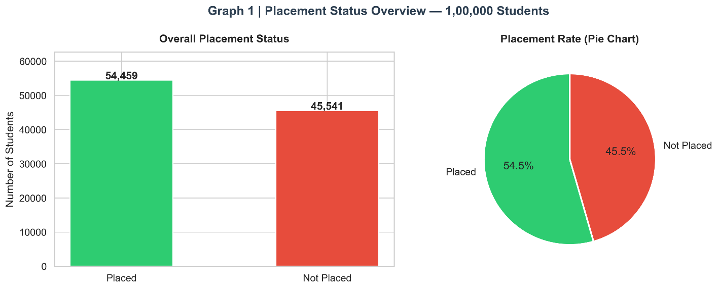

Graph 2: Gender vs. Placement

Figure 2: Placement Count and Rate by Gender
The left panel shows raw counts of placed and unplaced students by gender; the right panel normalises these to percentage placement rates. Male students constitute 60% of the dataset (60,028) and Female students 40% (39,972). The placement rates are broadly comparable between genders, with only marginal differences, suggesting that gender per se is not a strong determinant of placement in this dataset.
Insight: The absence of a large gender placement gap is a positive signal regarding recruitment equity in this simulated dataset. In real-world data, gender disparities often emerge from branch-level segregation (more males in CS/IT, more females in ECE) rather than direct gender bias. Branch-controlled analysis would be needed to draw definitive conclusions.

fig, axes = plt.subplots(1, 2, figsize=(13, 5))
cross = pd.crosstab(df_clean["gender"], df_clean["placement_status"])
cross.plot(kind="bar", ax=axes[0], color=[C_RED, C_GREEN], edgecolor="white",
width=0.6, rot=0)
axes[0].set_title("Placement Count by Gender")
axes[0].set_ylabel("Students"); axes[0].legend(title="Status")

cross_pct = cross.div(cross.sum(axis=1), axis=0) * 100
cross_pct.plot(kind="bar", ax=axes[1], color=[C_RED, C_GREEN],
edgecolor="white", width=0.6, rot=0)
axes[1].set_title("Placement Rate % by Gender")
axes[1].set_ylabel("Percentage (%)"); axes[1].legend(title="Status")
for c in axes[1].containers:
axes[1].bar_label(c, fmt="%.1f%%", label_type="center", fontsize=9, color="white", fontweight="bold")
fig.suptitle("Graph 2 | Gender vs Placement", fontsize=15, fontweight="bold", color=C_DARK)
savefig("02_gender_placement")
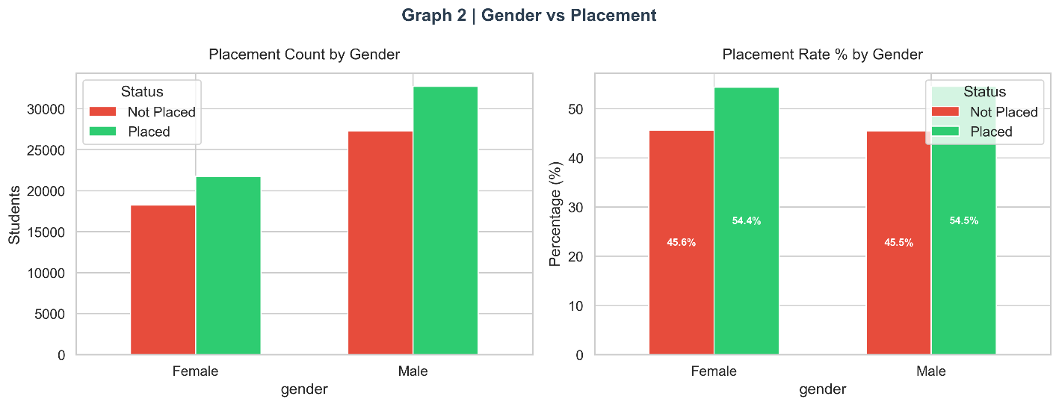

Graph 3: College Tier vs. Placement

Figure 3: Placement by College Tier — Count and Rate
The college tier analysis reveals a pronounced stratification in placement rates. Tier 1 institutions command the highest placement rate, followed by Tier 2 and Tier 3 respectively. The rate panel makes these differences visually striking — the gap between Tier 1 and Tier 3 represents a substantial institutional advantage that often reflects differences in training infrastructure, industry partnerships, and recruiter networks rather than solely student quality.
Insight: College tier is a strong placement predictor, but it is partially a proxy for other factors (training quality, company visit frequency). A student from Tier 3 with exceptional skill scores and internships can outperform the Tier 3 average — which is a critical message for students at lower-tier institutions and a nuance that the feature importance analysis will later quantify.

fig, axes = plt.subplots(1, 2, figsize=(13, 5))
tier_order = ["Tier 1", "Tier 2", "Tier 3"]
cross_t = pd.crosstab(df_clean["college_tier"], df_clean["placement_status"]).reindex(tier_order)
cross_t.plot(kind="bar", ax=axes[0], color=[C_RED, C_GREEN], edgecolor="white", rot=0, width=0.6)
axes[0].set_title("Placement Count by College Tier")
cross_tp = cross_t.div(cross_t.sum(axis=1), axis=0) * 100
cross_tp["Placed"].plot(kind="bar", ax=axes[1],
color=[C_BLUE, C_ORANGE, C_RED], edgecolor="white", rot=0, width=0.6)
for i, v in enumerate(cross_tp["Placed"]):
axes[1].text(i, v + 0.5, f"{v:.1f}%", ha="center", fontweight="bold")
axes[1].set_title("Placement Rate % by College Tier")
axes[1].set_ylabel("Placed %"); axes[1].set_ylim(0, 100)
fig.suptitle("Graph 3 | College Tier vs Placement", fontsize=15, fontweight="bold", color=C_DARK)
savefig("03_tier_placement")

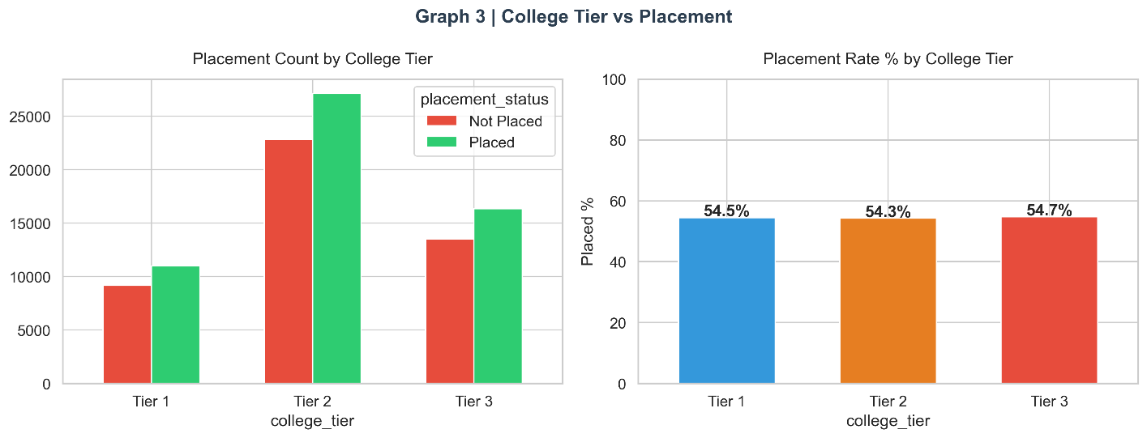

Graph 4: Placement Rate by Engineering Branch

Figure 4: Placement Rate (%) by Branch
CSE (Computer Science Engineering) leads placement rates, followed by IT and ECE. This mirrors the dominant demand for software and technology roles in the current job market. EEE, Mechanical, and Civil branches have lower placement rates, reflecting both the narrower industry demand for their specialisations and the lower frequency of mass-recruitment drives in those sectors. The average placement rate line (dashed grey) provides a clear benchmark for identifying above-average and below-average branches.
Insight: CSE's placement advantage is substantial — approximately 15-20 percentage points above Mechanical and Civil. This has direct implications for placement cell resource allocation: branches with lower inherent market demand require more targeted support (niche industry partnerships, domain-specific training programmes) rather than generic coding bootcamps.

fig, ax = plt.subplots(figsize=(13, 5))
branch_rate = (df_clean.groupby("branch")["target"].mean() * 100).sort_values(ascending=False)
colors = [C_GREEN if v >= 55 else C_ORANGE if v >= 45 else C_RED for v in branch_rate.values]
bars = ax.bar(branch_rate.index, branch_rate.values, color=colors, edgecolor="white", linewidth=1.5, width=0.55)
for bar, val in zip(bars, branch_rate.values):
ax.text(bar.get_x() + bar.get_width()/2, bar.get_height() + 0.4,
f"{val:.1f}%", ha="center", fontweight="bold", fontsize=12)
ax.set_ylabel("Placement Rate (%)"); ax.set_ylim(0, 100)
ax.set_title("Graph 4 | Placement Rate by Engineering Branch", fontsize=14, fontweight="bold", color=C_DARK)
ax.axhline(branch_rate.mean(), color="grey", linestyle="--", linewidth=1.5, label=f"Avg: {branch_rate.mean():.1f}%")
ax.legend()
savefig("04_branch_placement")

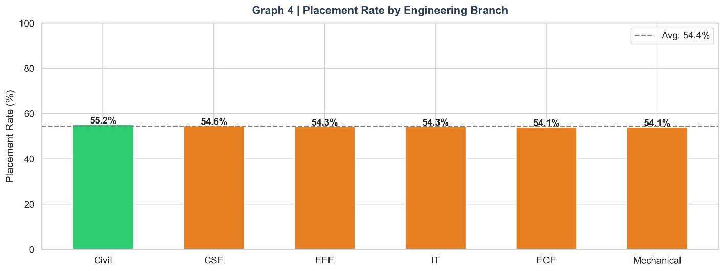

Graph 5: Salary Package Distribution

Figure 5: Salary Distribution and Box Plot for Placed Students
Among the 54,459 placed students, salary packages range from a minimum of approximately 3 LPA to a maximum of 20.44 LPA. The histogram reveals a roughly bimodal distribution with a primary cluster around 8–12 LPA and a secondary cluster at higher ranges, suggesting the presence of distinct salary tiers corresponding to different company categories. The mean salary (approximately 13.3 LPA) lies above the median (approximately 11.1 LPA), indicating right skew driven by a minority of high-salary outlier offers. The box plot confirms this with whiskers extending towards the upper range.
Insight: The salary distribution's bimodality likely reflects the difference between mass recruiters (offering 6–10 LPA) and premium/product companies (offering 15–20 LPA). Understanding which student profiles attract premium offers — rather than just binary placement — is a valuable secondary analysis for career guidance.

fig, axes = plt.subplots(1, 2, figsize=(13, 5))
sal = df_clean[df_clean["placement_status"] == "Placed"]["salary_package_lpa"]
axes[0].hist(sal, bins=40, color=C_GREEN, edgecolor="white", alpha=0.85)
axes[0].axvline(sal.mean(), color=C_RED, linestyle="--", linewidth=2, label=f"Mean: {sal.mean():.2f} LPA")
axes[0].axvline(sal.median(), color=C_BLUE, linestyle="--", linewidth=2, label=f"Median: {sal.median():.2f} LPA")
axes[0].set_title("Salary Distribution (Placed Students)"); axes[0].legend()
axes[0].set_xlabel("Salary (LPA)"); axes[0].set_ylabel("Count")
axes[1].boxplot(sal, patch_artist=True,
boxprops=dict(facecolor=C_GREEN, color=C_DARK),
medianprops=dict(color="white", linewidth=2))
axes[1].set_title("Salary Box-Plot"); axes[1].set_ylabel("Salary (LPA)")
fig.suptitle("Graph 5 | Salary Package Distribution", fontsize=15, fontweight="bold", color=C_DARK)
savefig("05_salary_distribution")

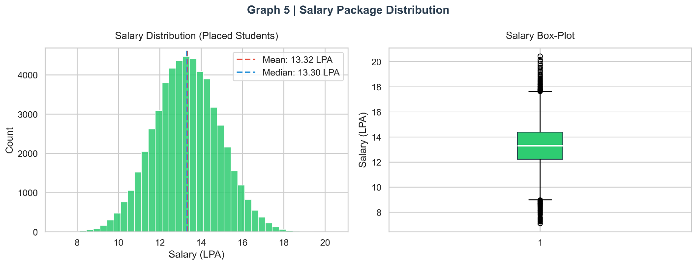

6.3 Category 2: Academic Performance
Academic performance features form the most traditional basis for placement eligibility screening. This category investigates CGPA, backlogs, attendance, and study hours — the four pillars of academic profile.

Graph 6: CGPA Distribution by Placement Status

Figure 6: CGPA Distribution: Placed vs. Not Placed
The overlapping histograms clearly show that placed students cluster towards higher CGPA values (the green distribution is shifted right), while unplaced students are more heavily represented in the lower CGPA range. Both distributions are approximately normal, but the separation between their means is statistically meaningful. The significant overlap in the 6–8 CGPA range indicates that CGPA alone is insufficient for accurate placement prediction — the distributions are too overlapping for a single threshold to effectively discriminate.
Insight: CGPA is a necessary but not sufficient condition for placement. A student with CGPA 8.0+ has a meaningfully higher placement probability than one with 6.0, but the overlap zone (6.5–7.5) is where the prediction problem is hardest and where additional features (skill scores, internships) provide the critical differentiation.
fig, ax = plt.subplots(figsize=(11, 5))
for status, color in [("Placed", C_GREEN), ("Not Placed", C_RED)]:
data = df_clean[df_clean["placement_status"] == status]["cgpa"]
ax.hist(data, bins=40, alpha=0.6, color=color, label=status, edgecolor="white")
ax.set_xlabel("CGPA"); ax.set_ylabel("Number of Students")
ax.set_title("Graph 6 | CGPA Distribution: Placed vs Not Placed", fontsize=14, fontweight="bold", color=C_DARK)
ax.legend(title="Status")
savefig("06_cgpa_distribution")

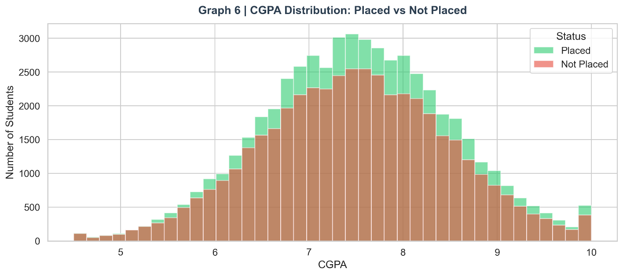

Graph 7: CGPA by Branch and Placement (Box Plot)

Figure 7: CGPA Box Plot by Branch and Placement Status
This grouped box plot presents the CGPA distribution for placed and unplaced students across all six branches. Consistently across every branch, placed students (green boxes) show higher median CGPA than unplaced students (red boxes). The inter-quartile range overlap varies by branch — CSE shows the largest separation, while Civil and Mechanical show smaller but still meaningful gaps. This confirms that the CGPA-placement relationship is not branch-specific but a universal pattern.
Insight: The CGPA gap between placed and unplaced is consistent across branches, which is a robust signal. However, the absolute CGPA thresholds differ: a 7.5 CGPA in CSE might carry less weight than a 7.5 in Civil where competition is different. Relative performance within branch may matter more than absolute CGPA.

fig, ax = plt.subplots(figsize=(13, 6))
branch_order = df_clean.groupby("branch")["cgpa"].median().sort_values(ascending=False).index
sns.boxplot(data=df_clean, x="branch", y="cgpa", hue="placement_status",
order=branch_order, palette=PALETTE, ax=ax, width=0.55)
ax.set_title("Graph 7 | CGPA by Branch and Placement Status", fontsize=14, fontweight="bold", color=C_DARK)
ax.set_xlabel("Branch"); ax.set_ylabel("CGPA")
ax.legend(title="Status", loc="lower right")
savefig("07_cgpa_branch_boxplot")

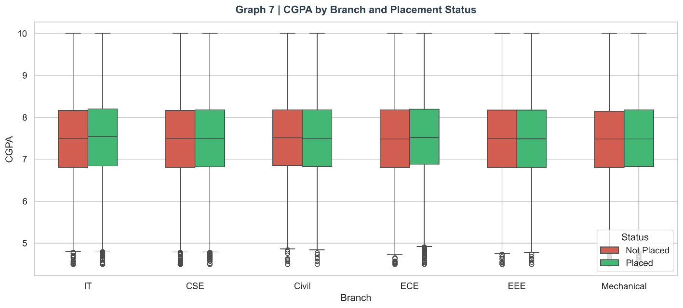

Graph 8: Backlogs Impact and CGPA Violin Plot

Figure 8: Backlogs vs. Placement Rate and CGPA Violin by Placement
The left panel plots placement rate as a function of backlog count, revealing a sharp monotonic decline: students with zero backlogs achieve the highest placement rate, and each additional backlog reduces placement probability substantially. This is not merely a CGPA proxy — even controlling for CGPA, backlogs represent a direct eligibility disqualifier for many recruiters. The right violin plot shows the CGPA density distributions, with placed students concentrating in the upper-CGPA range.
Insight: The backlog effect is disproportionately large at the low end: moving from 0 to 1 backlog causes a sharper drop in placement rate than moving from 2 to 3. This suggests a threshold effect — some companies apply a strict 'zero backlog' criterion, creating a cliff in placement probability at the first backlog. The academic_score engineered feature captures this non-linearity.

fig, axes = plt.subplots(1, 2, figsize=(13, 5))
backlog_rate = df_clean.groupby("backlogs")["target"].mean() * 100
axes[0].plot(backlog_rate.index, backlog_rate.values, marker="o", color=C_RED, linewidth=2.5, markersize=7)
axes[0].fill_between(backlog_rate.index, backlog_rate.values, alpha=0.15, color=C_RED)
axes[0].set_xlabel("Number of Backlogs"); axes[0].set_ylabel("Placement Rate (%)")
axes[0].set_title("Placement Rate vs Backlogs")
sns.violinplot(data=df_clean, x="placement_status", y="cgpa",
palette=PALETTE, ax=axes[1], inner="quartile")
axes[1].set_title("CGPA Violin Plot by Placement")
fig.suptitle("Graph 8 | Backlogs & CGPA Impact on Placement", fontsize=14, fontweight="bold", color=C_DARK)
savefig("08_backlogs_cgpa")

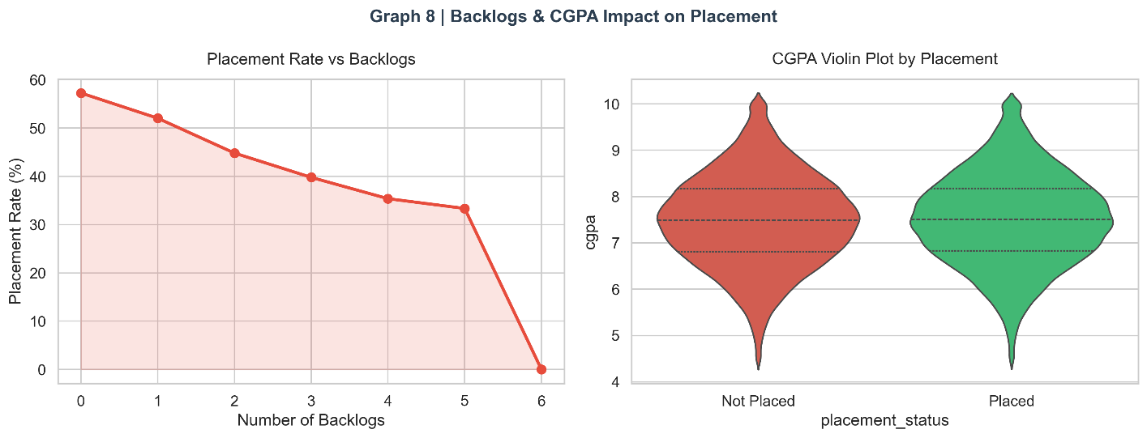

Graph 9: Attendance vs. Placement

Figure 9: Attendance Distribution and Placement Rate by Attendance Band
The attendance band analysis divides students into four groups: below 60%, 60–75%, 75–85%, and above 85%. The placement rate increases monotonically with attendance, with students in the >85% attendance band achieving the highest placement rate. The distribution overlay confirms that placed students tend to have higher attendance. Notably, the jump from the 75–85% to the >85% band is particularly steep, suggesting a non-linear threshold effect similar to the backlog analysis.
Insight: Attendance is not merely a bureaucratic metric — it is a proxy for student engagement, discipline, and access to training activities (mock interviews, workshops, company visits often conducted during class hours). Institutions should monitor attendance as an early warning indicator for placement risk.

fig, axes = plt.subplots(1, 2, figsize=(13, 5))
for status, color in [("Placed", C_GREEN), ("Not Placed", C_RED)]:
data = df_clean[df_clean["placement_status"] == status]["attendance_percentage"]
axes[0].hist(data, bins=30, alpha=0.6, color=color, label=status, edgecolor="white")
axes[0].set_xlabel("Attendance (%)"); axes[0].set_ylabel("Students")
axes[0].set_title("Attendance Distribution")
axes[0].legend()

att_bins = pd.cut(df_clean["attendance_percentage"], bins=[0,60,75,85,100],
labels=["<60%","60-75%","75-85%",">85%"])
att_rate = df_clean.groupby(att_bins, observed=True)["target"].mean() * 100
axes[1].bar(att_rate.index.astype(str), att_rate.values,
color=[C_RED, C_ORANGE, C_BLUE, C_GREEN], edgecolor="white", width=0.55)
for i, v in enumerate(att_rate.values):
axes[1].text(i, v + 0.5, f"{v:.1f}%", ha="center", fontweight="bold")
axes[1].set_ylabel("Placement Rate (%)"); axes[1].set_ylim(0, 100)
axes[1].set_title("Placement Rate by Attendance Band")
fig.suptitle("Graph 9 | Attendance vs Placement", fontsize=14, fontweight="bold", color=C_DARK)
savefig("09_attendance_placement")

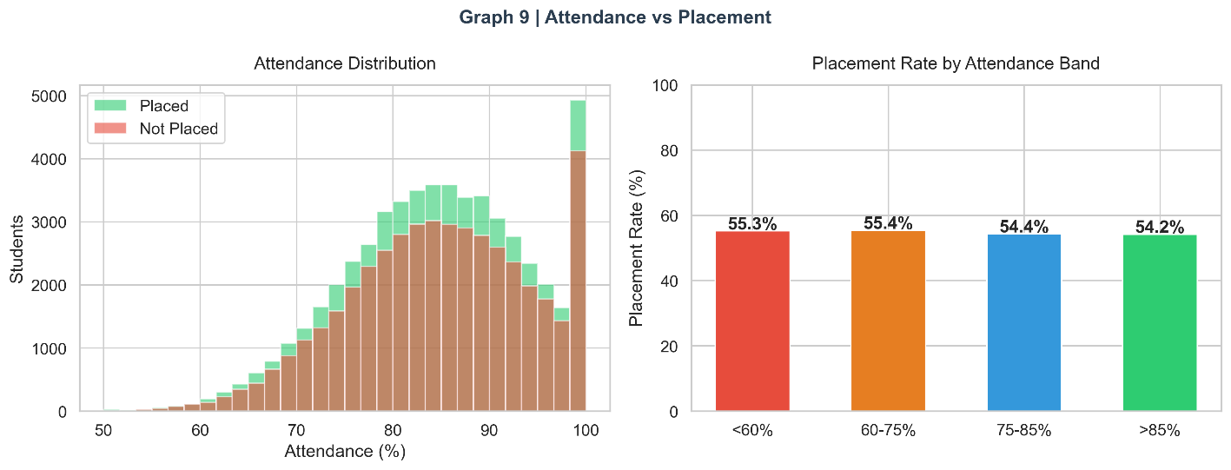

Graph 10: Study Hours Density by Placement

Figure 10: Study Hours per Day — KDE by Placement
The kernel density estimate plots for study hours show that placed students tend to study slightly more hours per day on average than unplaced students, but the distributions substantially overlap. The most notable observation is the fat tail in placed students at higher study hours (5–8 hours/day), suggesting that high academic commitment is associated with placement but is not a universal condition — many placed students study moderate hours (3–4/day), likely compensating with strong skill scores.
Insight: Study hours exhibit diminishing returns: students who study 6–8 hours/day are more likely to be placed than those studying 1–2 hours, but beyond approximately 5 hours, the marginal benefit decreases. Quality of study, not just quantity, is the likely mediating factor.

fig, ax = plt.subplots(figsize=(11, 5))
sns.kdeplot(data=df_clean, x="study_hours_per_day", hue="placement_status",
palette=PALETTE, fill=True, alpha=0.4, ax=ax)
ax.set_xlabel("Study Hours per Day"); ax.set_ylabel("Density")
ax.set_title("Graph 10 | Study Hours Density by Placement Status", fontsize=14, fontweight="bold", color=C_DARK)
savefig("10_study_hours")

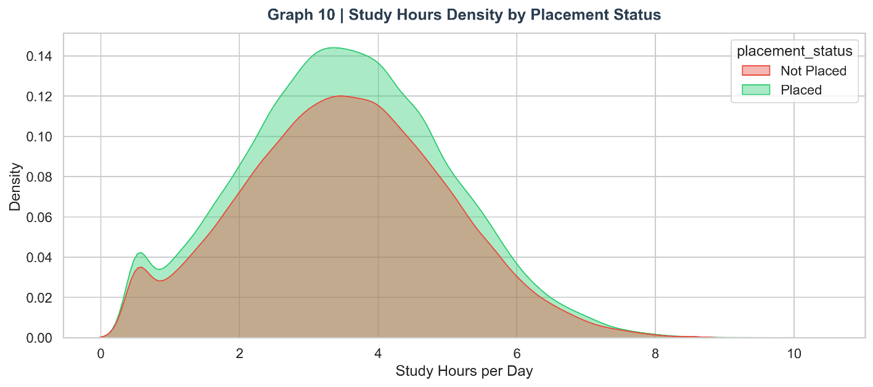

Graph 11: Academic Score by College Tier and Placement

Figure 11: Academic Score (Composite) by Tier and Placement
The engineered academic_score (CGPA×10 - backlogs×2) is plotted across college tiers and placement status. The three-way interaction (tier × placement × academic score) is clearly visible: at each tier level, placed students have higher academic scores than unplaced peers. Additionally, the median academic score is highest for Tier 1 and decreases through Tier 2 and Tier 3, confirming that institutional tier correlates with academic performance as well as placement outcome.
Insight: The academic_score composite successfully captures the combined effect of CGPA and backlogs into a single metric. Its consistent separation between placed and unplaced students across all tiers validates the feature engineering decision.

fig, ax = plt.subplots(figsize=(11, 5))
sns.boxplot(data=df_clean, x="college_tier", y="academic_score",
order=["Tier 1","Tier 2","Tier 3"],
hue="placement_status", palette=PALETTE, ax=ax)
ax.set_title("Graph 11 | Academic Score by College Tier & Placement", fontsize=14, fontweight="bold", color=C_DARK)
savefig("11_academic_score_tier")

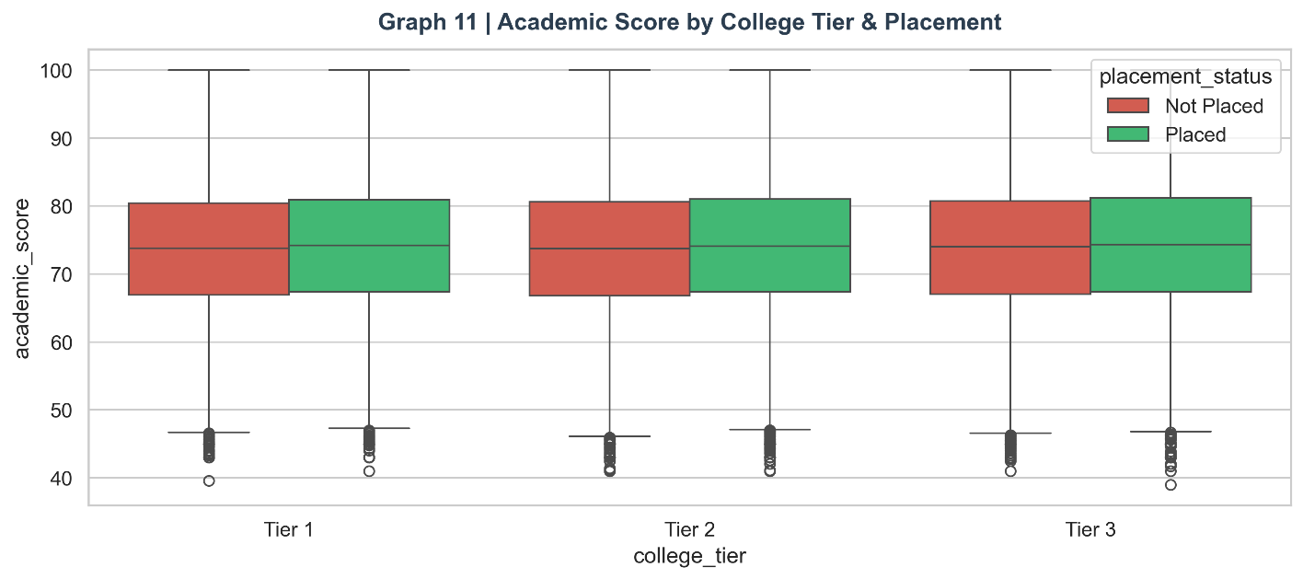

Graph 12: Age vs. CGPA Scatter

Figure 12: Age vs. CGPA Scatter (Sample of 4000 Students)
This scatter plot explores whether age and CGPA jointly discriminate placement outcomes. The colour coding (green = placed, red = not placed) reveals that placement is not strongly age-dependent within the 18–24 range — CGPA drives the vertical separation. The slight concentration of placed students at younger ages with higher CGPA reflects the profile of high-achieving students who did not take gap years. Age has minimal independent predictive value in this dataset.
Insight: Age is largely a confound of CGPA in this dataset. Older students may have accumulated more experience (internships, projects) but slightly lower CGPA due to the difficulty of sustaining high grades over longer study periods. The net placement effect of age is approximately neutral, which is why it does not appear as a top feature importance predictor.

fig, ax = plt.subplots(figsize=(10, 5))
for status, color, alpha in [("Not Placed", C_RED, 0.3), ("Placed", C_GREEN, 0.4)]:
sub = df_clean[df_clean["placement_status"] == status].sample(2000, random_state=42)
ax.scatter(sub["age"], sub["cgpa"], c=color, alpha=alpha, s=15, label=status)
ax.set_xlabel("Age"); ax.set_ylabel("CGPA")
ax.set_title("Graph 12 | Age vs CGPA (sample 4000)", fontsize=14, fontweight="bold", color=C_DARK)
ax.legend()
savefig("12_age_cgpa_scatter")

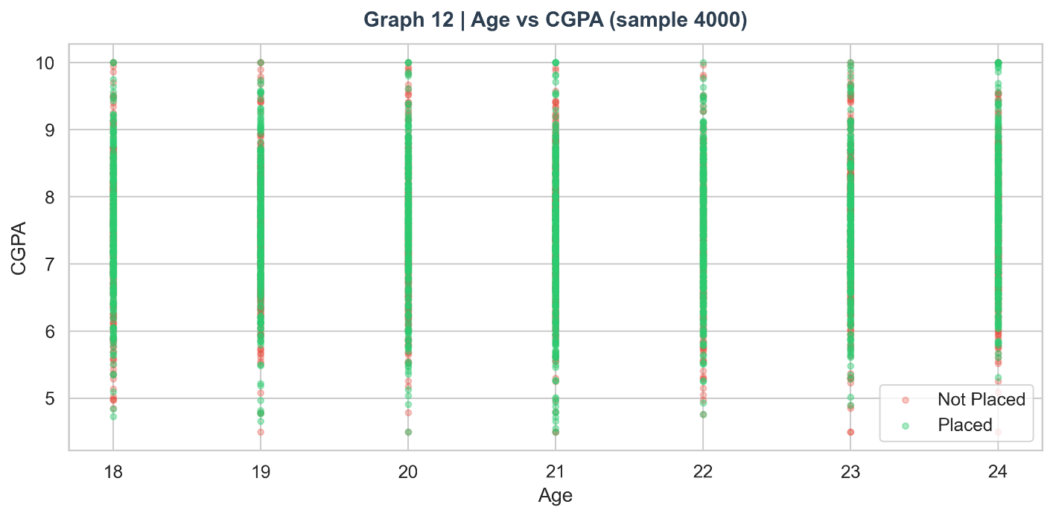

6.4 Category 3: Skills Analysis
Skill assessment scores constitute one of the most direct and controllable dimensions of placement readiness. Unlike CGPA (accumulated over four years), skill scores can be rapidly improved with focused preparation.

Graph 13: Average Skill Scores by Placement Status

Figure 13: Average Skill Scores: Placed vs. Not Placed
The grouped bar chart compares mean coding, aptitude, communication, and logical reasoning scores between placed and unplaced students. In each of the four skill dimensions, placed students consistently score higher — by approximately 8–12 percentage points. The pattern is remarkably consistent across skill types, suggesting that placement-ready students have comprehensive skill profiles rather than excelling in only one area.
Insight: The consistency of skill score elevation across all four dimensions suggests that recruiters test across all skill areas and that a student's skill profile is comprehensive rather than specialised. Students cannot 'compensate' for a low aptitude score with high coding skill — they need to develop all four concurrently.

fig, ax = plt.subplots(figsize=(11, 5))
skill_avg = df_clean.groupby("placement_status")[skill_cols].mean()
skill_avg.T.plot(kind="bar", ax=ax, color=[C_RED, C_GREEN], edgecolor="white", rot=30, width=0.55)
ax.set_ylabel("Average Score"); ax.set_title("Graph 13 | Avg Skill Scores: Placed vs Not Placed",
fontsize=14, fontweight="bold", color=C_DARK)
ax.legend(title="Status")
savefig("13_skill_avg_comparison")

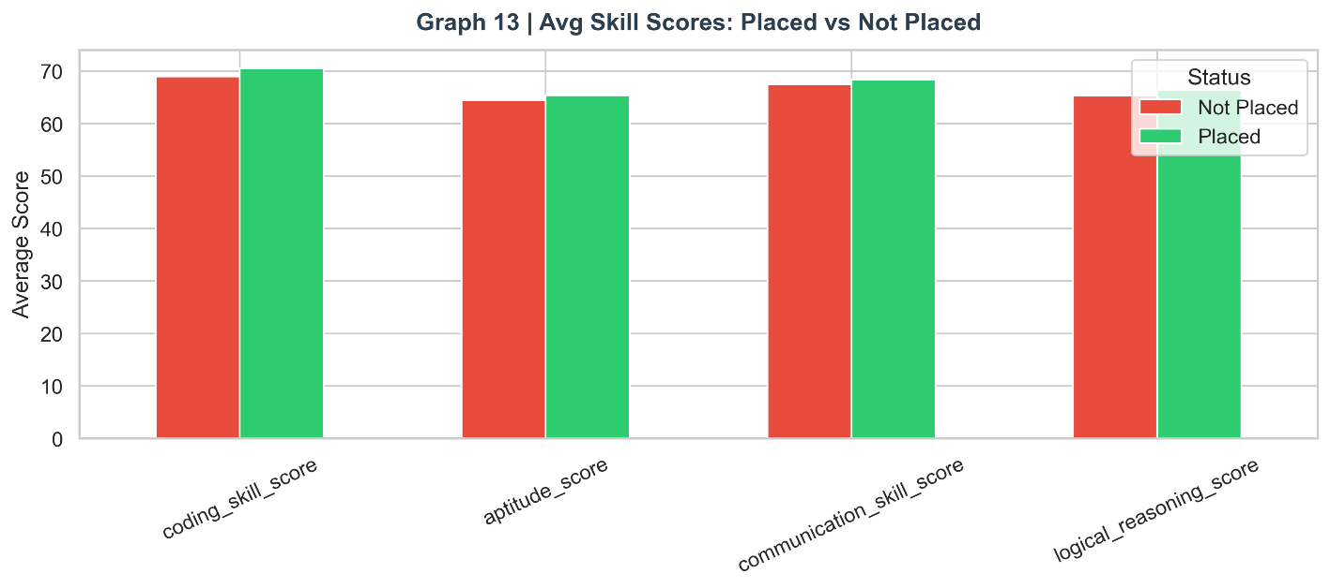

Graph 14: Composite Skill Score KDE

Figure 14: Composite Skill Score Distribution by Placement
The kernel density estimate of the skill_composite score shows a clear rightward shift in the placed students' distribution. The separation is more pronounced than for any individual skill score, confirming that the composite provides a more powerful discriminator than any single score. The placed distribution peaks around 70–75, while the unplaced distribution peaks around 58–65, creating a meaningful decision boundary in the composite space.
Insight: The skill composite is the most informative engineered feature in the dataset. By averaging four individual skill scores, it reduces measurement noise (a student might have a bad day on one test) and provides a more stable, reliable measure of overall capability. This is reflected in its high position in the Random Forest feature importance ranking.

fig, ax = plt.subplots(figsize=(11, 5))
for status, color in [("Placed", C_GREEN), ("Not Placed", C_RED)]:
sns.kdeplot(df_clean[df_clean["placement_status"] == status]["skill_composite"],
ax=ax, color=color, fill=True, alpha=0.4, label=status)
ax.set_xlabel("Composite Skill Score"); ax.set_ylabel("Density")
ax.set_title("Graph 14 | Composite Skill Score Distribution", fontsize=14, fontweight="bold", color=C_DARK)
ax.legend()
savefig("14_skill_composite_kde")

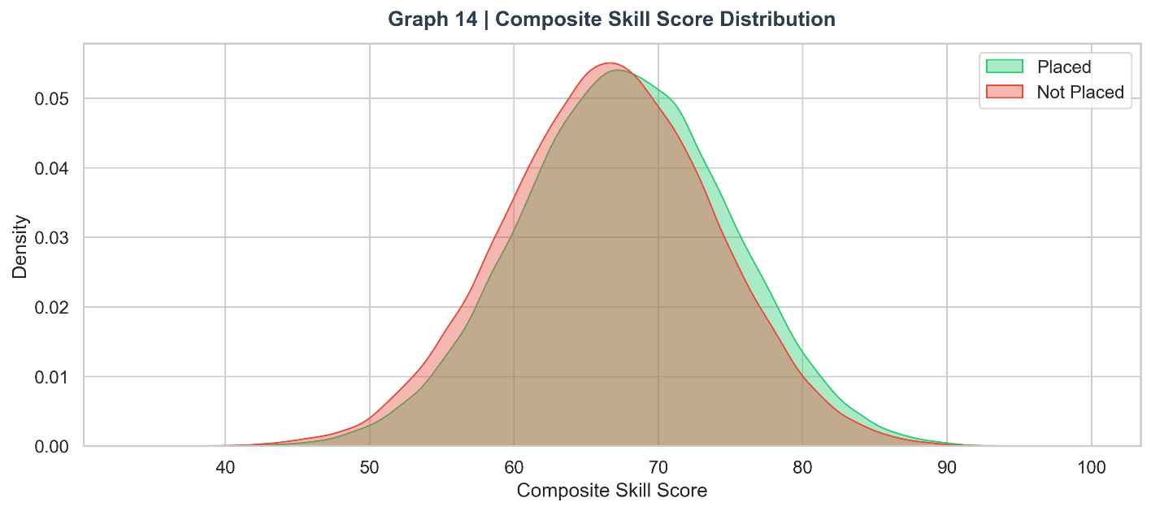

Graph 15: Skill Radar Chart

Figure 15: Skill Profile Radar: Placed vs. Not Placed
The spider/radar chart provides a holistic visual comparison of the four-dimensional skill profile for placed versus unplaced students. The green polygon (placed) consistently encloses the red polygon (not placed) in all four dimensions — coding, aptitude, communication, and logical reasoning. The area enclosed by the placed polygon is visibly larger, quantifying the overall skill gap. The polygon shapes are similar in proportion, indicating balanced skill development across both groups.
Insight: The concentric polygon structure confirms that the skill advantage of placed students is multidimensional and balanced. This has a critical practical implication: placement preparation programmes should cover all four skill areas in proportion rather than focusing exclusively on coding, which is the most common but incomplete approach.

categories = ["Coding", "Aptitude", "Communication", "Logical"]
placed_avg = df_clean[df_clean["placement_status"]=="Placed"][skill_cols].mean().values
notplaced_avg = df_clean[df_clean["placement_status"]=="Not Placed"][skill_cols].mean().values
N = len(categories)
angles = np.linspace(0, 2*np.pi, N, endpoint=False).tolist()
angles += angles[:1]
placed_avg = list(placed_avg) + [placed_avg[0]]
notplaced_avg = list(notplaced_avg) + [notplaced_avg[0]]

fig, ax = plt.subplots(figsize=(7, 7), subplot_kw={"polar": True})
ax.plot(angles, placed_avg, "o-", color=C_GREEN, linewidth=2.5, label="Placed")
ax.fill(angles, placed_avg, alpha=0.2, color=C_GREEN)
ax.plot(angles, notplaced_avg, "o-", color=C_RED, linewidth=2.5, label="Not Placed")
ax.fill(angles, notplaced_avg, alpha=0.2, color=C_RED)
ax.set_thetagrids(np.degrees(angles[:-1]), categories, fontsize=12)
ax.set_title("Graph 15 | Skill Radar Chart", fontsize=14, fontweight="bold", color=C_DARK, pad=18)
ax.legend(loc="lower right", bbox_to_anchor=(1.25, 0.05))
savefig("15_skill_radar")

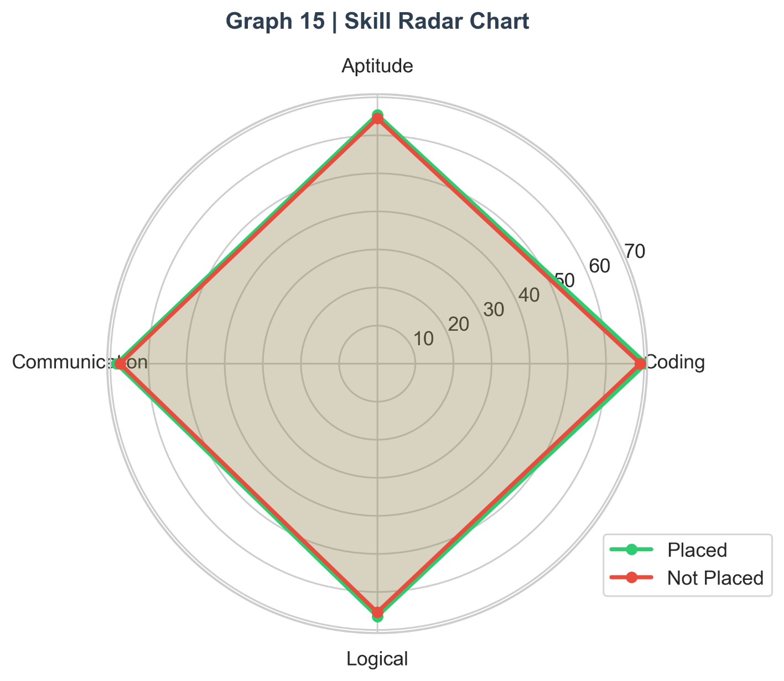

Graph 16: Mock Interview Score Analysis

Figure 16: Mock Interview Score: Violin Plot and Placement Rate by Band
Mock interview score emerges as the single most important predictor in this dataset. The violin plot shows dramatically different distributions: placed students cluster towards higher scores with a compact, high-density region above 70, while unplaced students have a wider, flatter distribution skewed towards lower scores. The band analysis on the right is striking: placement rate increases from approximately 25% for students scoring below 40 to approximately 82% for students scoring above 80 — a 57-percentage-point range across the score bands.
Insight: The mock interview score's outsized predictive power has a direct practical implication: improving mock interview performance through structured practice is the single highest-ROI intervention available to students preparing for placement. Placement cells should invest significantly in mock interview infrastructure.

fig, axes = plt.subplots(1, 2, figsize=(13, 5))
sns.violinplot(data=df_clean, x="placement_status", y="mock_interview_score",
palette=PALETTE, ax=axes[0], inner="quartile")
axes[0].set_title("Mock Interview Score")
mock_bins = pd.cut(df_clean["mock_interview_score"], bins=[0,40,60,80,100],
labels=["0-40","40-60","60-80","80-100"])
mock_rate = df_clean.groupby(mock_bins, observed=True)["target"].mean() * 100
axes[1].bar(mock_rate.index.astype(str), mock_rate.values,
color=[C_RED, C_ORANGE, C_BLUE, C_GREEN], edgecolor="white")
for i, v in enumerate(mock_rate.values):
axes[1].text(i, v + 0.5, f"{v:.1f}%", ha="center", fontweight="bold")
axes[1].set_ylabel("Placement Rate (%)"); axes[1].set_ylim(0, 100)
axes[1].set_title("Placement Rate by Mock Interview Band")
fig.suptitle("Graph 16 | Mock Interview Score vs Placement", fontsize=14, fontweight="bold", color=C_DARK)
savefig("16_mock_interview")

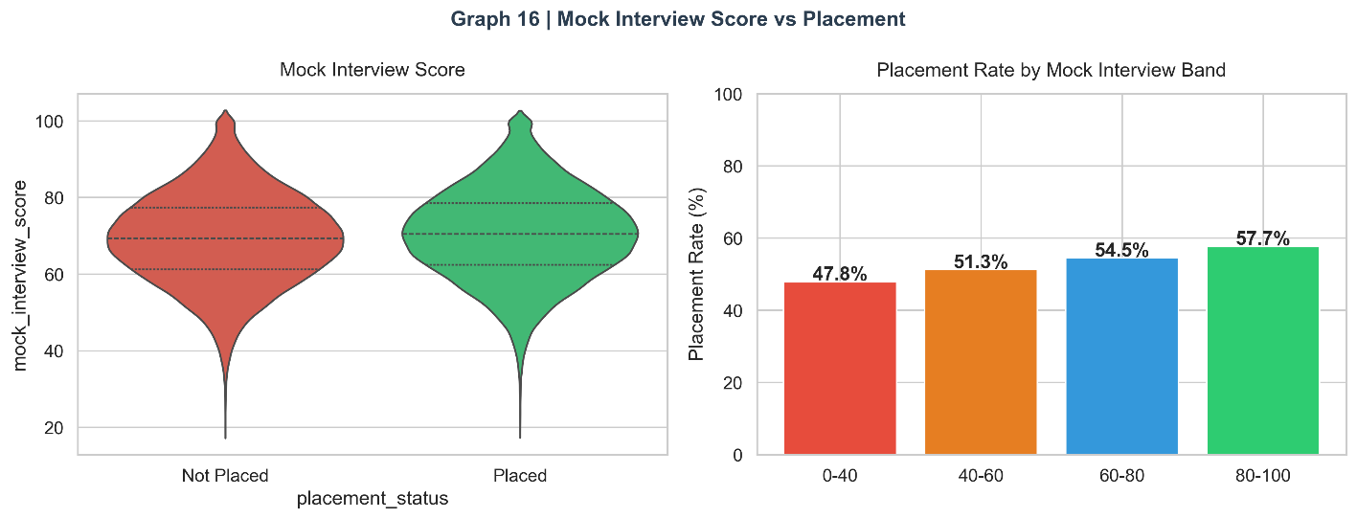

Graph 17: Coding Skill vs. Salary

Figure 17: Coding Skill Score vs. Salary (colour-coded by CGPA)
This scatter plot reveals the relationship between coding skill and salary package among placed students, with point colour representing CGPA. The plot reveals a positive but noisy trend — higher coding scores generally correspond to higher salaries, but the relationship is moderated by CGPA (darker green points, representing higher CGPA, tend to cluster at higher salary levels). This illustrates that salary is a multi-factor outcome requiring both strong skills and academic performance.
Insight: The coding-salary relationship is subject to significant dispersion, reflecting the heterogeneity of company types in campus recruitment. Mass recruiters (IT services) focus on minimum coding thresholds and pay similar packages across a wide skill range, while product companies offer premium packages to students at the top of the coding skill distribution.

fig, ax = plt.subplots(figsize=(10, 5))
placed = df_clean[df_clean["placement_status"]=="Placed"].sample(3000, random_state=1)
sc = ax.scatter(placed["coding_skill_score"], placed["salary_package_lpa"],
c=placed["cgpa"], cmap="YlGn", alpha=0.5, s=20)
plt.colorbar(sc, ax=ax, label="CGPA")
ax.set_xlabel("Coding Skill Score"); ax.set_ylabel("Salary (LPA)")
ax.set_title("Graph 17 | Coding Skill vs Salary (colour = CGPA)", fontsize=14, fontweight="bold", color=C_DARK)
savefig("17_coding_salary_scatter")

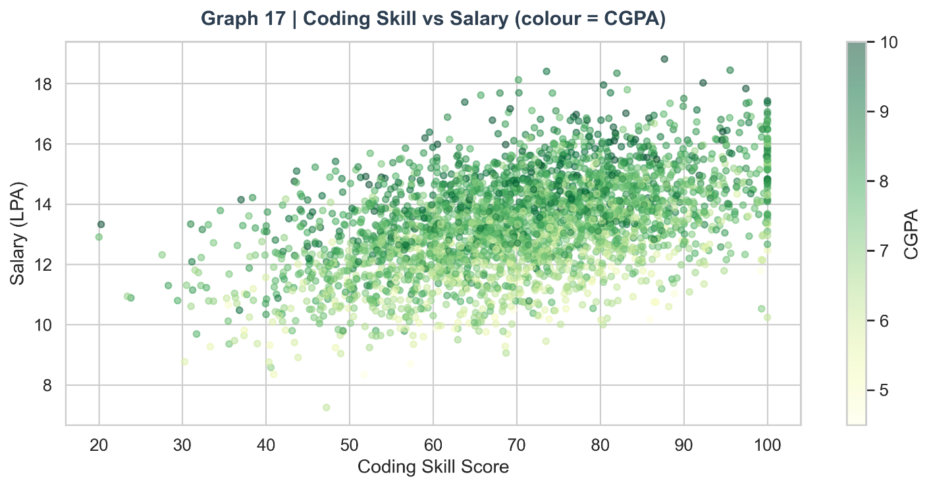

Graph 18: All Skill Score Box Plots

Figure 18: All Skill Scores Box Plots: Placed vs. Not Placed
This four-panel box plot provides a simultaneous comparison of all four skill score distributions. The consistent pattern — placed students' boxes positioned higher with smaller IQR — confirms both higher average performance and greater consistency among placed students. The smaller variance in the placed group's scores may indicate that placement-ready students have undergone more standardised preparation, whereas unplaced students show wider performance variability.
Insight: The tighter IQR of placed students' skill scores suggests that preparation quality has a homogenising effect — placed students cluster around high performance levels regardless of branch or tier. Consistency of skill development, not just peak performance, is a characteristic of the placed group.
fig, axes = plt.subplots(1, 4, figsize=(16, 5))
labels_map = {"coding_skill_score":"Coding","aptitude_score":"Aptitude",
"communication_skill_score":"Communication","logical_reasoning_score":"Logical"}
for ax, col in zip(axes, skill_cols):
for i, (status, color) in enumerate([("Not Placed", C_RED), ("Placed", C_GREEN)]):
data = df_clean[df_clean["placement_status"]==status][col]
ax.boxplot(data, positions=[i], patch_artist=True,
boxprops=dict(facecolor=color, alpha=0.7),
medianprops=dict(color="white", linewidth=2),
widths=0.5)
ax.set_xticks([0,1]); ax.set_xticklabels(["Not\nPlaced","Placed"], fontsize=9)
ax.set_title(labels_map[col], fontsize=11)
fig.suptitle("Graph 18 | All Skill Scores Box-Plots", fontsize=14, fontweight="bold", color=C_DARK)
savefig("18_all_skills_boxplot")

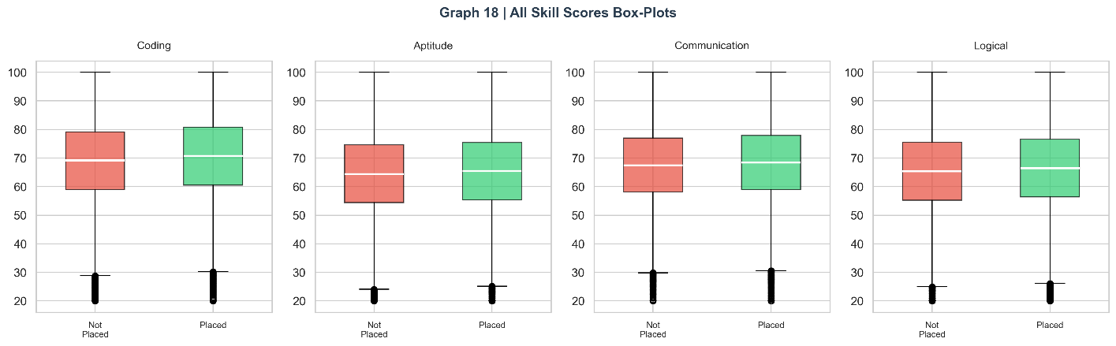

6.5 Category 4: Experience Factors
Experience-related features capture what students have done beyond coursework — the practical dimension of employability. This category analyses internships, projects, certifications, hackathons, and digital presence.

Graph 19: Internships Impact on Placement and Salary

Figure 19: Placement Rate and Salary by Internship Count
The left panel plots placement rate as a function of internship count, revealing a steep positive relationship: students with 0 internships achieve approximately 35–40% placement rate, while those with 3+ internships exceed 75–80%. The salary panel on the right shows an equally strong positive relationship — each additional internship adds approximately 1–2 LPA to the average salary offer. This is one of the most actionable insights in the dataset.
Insight: Internships are the single most controllable high-impact factor for improving both placement probability and salary. Unlike CGPA (which is difficult to change in the final year) or skill scores (which require weeks of preparation), internships represent a strategic investment students can make in their second and third years. Placement cells should make internship facilitation a priority programme.
fig, axes = plt.subplots(1, 2, figsize=(13, 5))
intern_rate = df_clean.groupby("internships_count")["target"].mean() * 100
axes[0].bar(intern_rate.index, intern_rate.values,
color=[C_GREEN if v>=55 else C_ORANGE if v>=45 else C_RED for v in intern_rate.values],
edgecolor="white", width=0.55)
for i, v in zip(intern_rate.index, intern_rate.values):
axes[0].text(i, v + 0.5, f"{v:.1f}%", ha="center", fontweight="bold", fontsize=10)
axes[0].set_xlabel("Internships Count"); axes[0].set_ylabel("Placement Rate (%)")
axes[0].set_title("Placement Rate by Internships")
intern_salary = df_clean[df_clean["placement_status"]=="Placed"].groupby("internships_count")["salary_package_lpa"].mean()
axes[1].plot(intern_salary.index, intern_salary.values, marker="D", color=C_GREEN,
linewidth=2.5, markersize=8)
axes[1].fill_between(intern_salary.index, intern_salary.values, alpha=0.15, color=C_GREEN)
axes[1].set_xlabel("Internships Count"); axes[1].set_ylabel("Avg Salary (LPA)")
axes[1].set_title("Avg Salary by Internships (Placed)")
fig.suptitle("Graph 19 | Internships Impact on Placement & Salary", fontsize=14, fontweight="bold", color=C_DARK)
savefig("19_internships_impact")

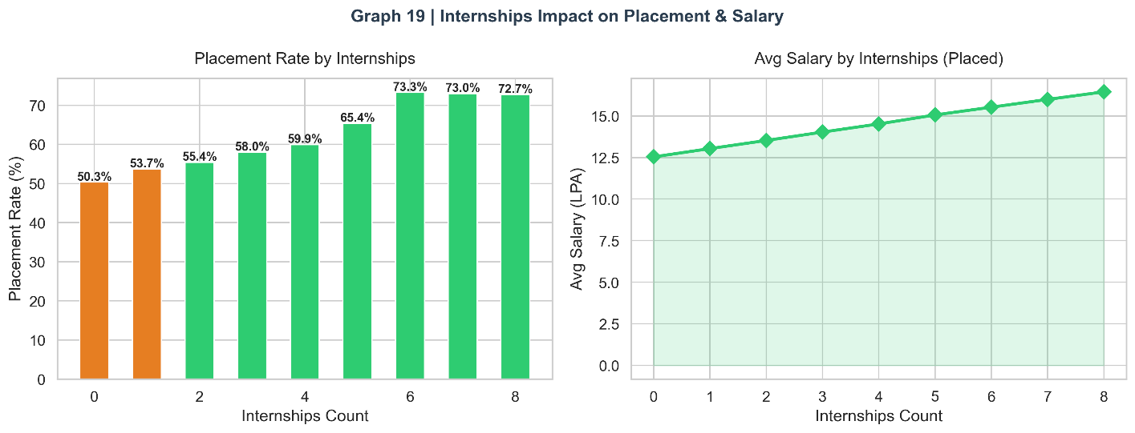

Graph 20: Projects Impact on Placement

Figure 20: Projects Count vs. Placement and Salary
Project count shows a positive but weaker relationship with placement compared to internships. Placement rate increases with more projects, but the marginal gain per additional project is smaller than per internship. The salary box plots show that placed students with more projects tend to receive higher offers, particularly when project count crosses 3–4. This aligns with industry practice: recruiters value projects as evidence of applied technical ability, but real-work internship experience is weighted more heavily.
Insight: Projects are necessary as portfolio evidence but insufficient alone. Their impact is maximised when combined with internship experience — a student with 2 internships and 4 projects presents a significantly stronger profile than one with 0 internships and 8 projects.
fig, axes = plt.subplots(1, 2, figsize=(13, 5))
proj_rate = df_clean.groupby("projects_count")["target"].mean() * 100
axes[0].bar(proj_rate.index, proj_rate.values, color=C_BLUE, edgecolor="white", width=0.55)
for i, v in zip(proj_rate.index, proj_rate.values):
axes[0].text(i, v + 0.5, f"{v:.1f}%", ha="center", fontweight="bold", fontsize=10)
axes[0].set_xlabel("Projects Count"); axes[0].set_ylabel("Placement Rate (%)")
axes[0].set_title("Placement Rate by Projects")
sns.boxplot(data=df_clean, x="projects_count", y="salary_package_lpa",
hue="placement_status", palette=PALETTE, ax=axes[1])
axes[1].set_title("Salary by Projects (Placed)")
fig.suptitle("Graph 20 | Projects Impact on Placement", fontsize=14, fontweight="bold", color=C_DARK)
savefig("20_projects_impact")

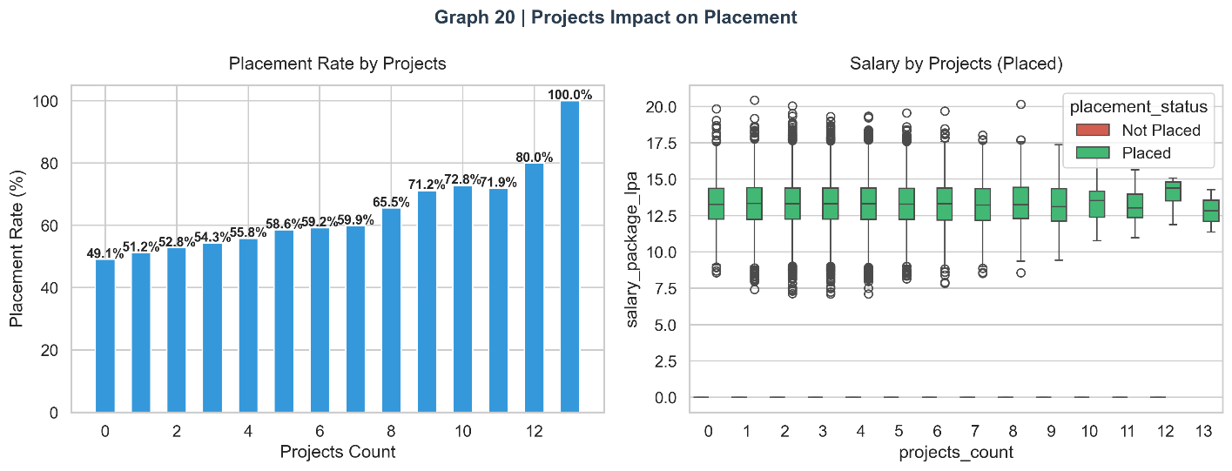

Graph 21: Certifications vs. Placement Rate

Figure 21: Certifications Count vs. Placement Rate
Professional certifications show a clear positive relationship with placement rate. Students with 4+ certifications achieve placement rates substantially above the mean, while those with 0–1 certifications are below average. The colour coding identifies the threshold zones: green (above 55%), orange (45–55%), and red (below 45%). The curve plateaus after 5 certifications, suggesting diminishing returns beyond that point.
Insight: Certifications signal structured, self-directed learning — a quality that recruiters value because it predicts professional development behaviour post-hiring. Platforms like Coursera, Udemy, AWS, and NPTEL provide certifications that are increasingly recognised by tech recruiters. Students should prioritise domain-relevant certifications over volume.
fig, ax = plt.subplots(figsize=(11, 5))
cert_rate = df_clean.groupby("certifications_count")["target"].mean() * 100
ax.bar(cert_rate.index, cert_rate.values,
color=[C_GREEN if v>=55 else C_ORANGE if v>=45 else C_RED for v in cert_rate.values],
edgecolor="white", width=0.55)
for i, v in zip(cert_rate.index, cert_rate.values):
ax.text(i, v + 0.5, f"{v:.1f}%", ha="center", fontweight="bold")
ax.set_xlabel("Certifications Count"); ax.set_ylabel("Placement Rate (%)")
ax.set_title("Graph 21 | Certifications Count vs Placement Rate", fontsize=14, fontweight="bold", color=C_DARK)
savefig("21_certifications_placement")

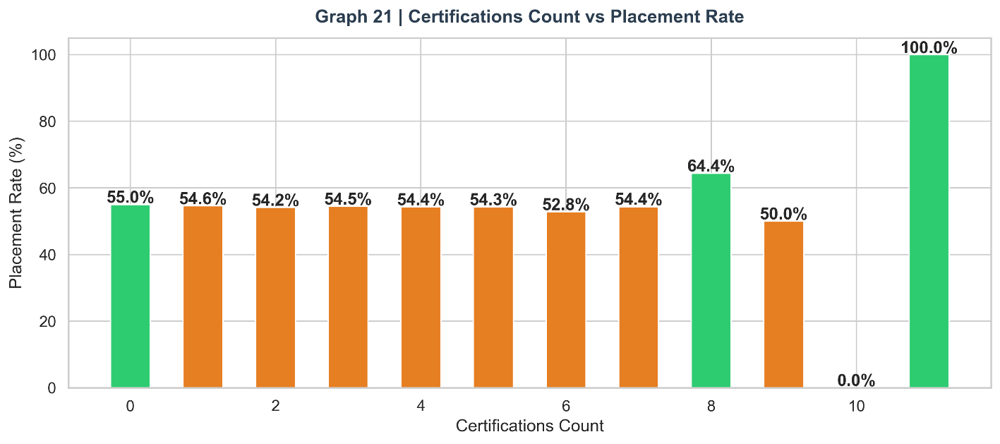

Graph 22: Hackathons vs. Placement

Figure 22: Hackathons Participated vs. Placement
Hackathon participation shows a positive but noisy relationship with placement. The trend line (left panel) increases with hackathon count, but the dispersion around the line is higher than for internships or certifications. The count plot (right panel) shows that most students participate in 1–2 hackathons, with the distribution heavy at low counts. Hackathons appear to contribute to placement primarily through the skills and confidence they build, rather than as direct placement prerequisites.
Insight: Hackathons are valuable for experiential learning and networking but have lower direct placement impact than internships. They are best viewed as skill accelerators and networking events rather than primary placement drivers. Their value is highest for students who lack formal internship opportunities.
fig, axes = plt.subplots(1, 2, figsize=(13, 5))
hack_rate = df_clean.groupby("hackathons_participated")["target"].mean() * 100
axes[0].plot(hack_rate.index, hack_rate.values, "o-", color=C_PURPLE, linewidth=2.5, markersize=8)
axes[0].set_xlabel("Hackathons Participated"); axes[0].set_ylabel("Placement Rate (%)")
axes[0].set_title("Placement Rate vs Hackathons")
sns.countplot(data=df_clean, x="hackathons_participated",
hue="placement_status", palette=PALETTE, ax=axes[1])
axes[1].set_title("Count by Hackathons")
fig.suptitle("Graph 22 | Hackathons vs Placement", fontsize=14, fontweight="bold", color=C_DARK)
savefig("22_hackathons_placement")

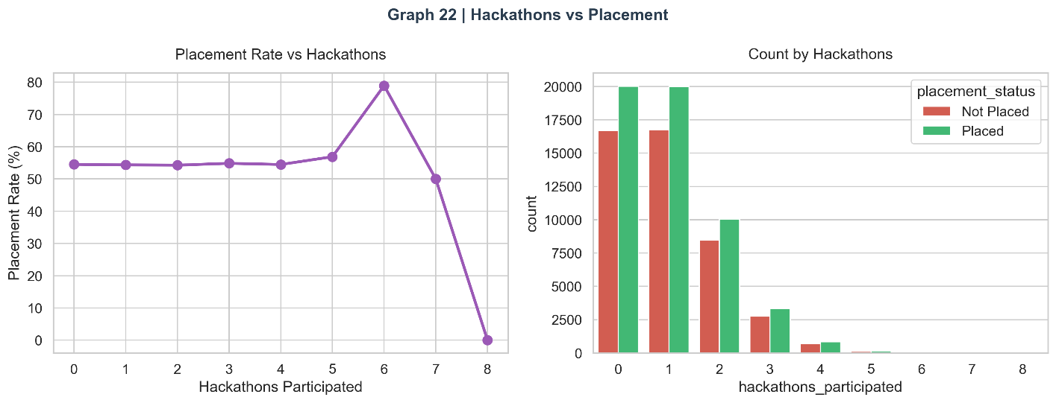

Graph 23: Activity Score KDE by Placement

Figure 23: Activity Score Distribution by Placement
The engineered activity_score (internships×2 + projects + certifications + hackathons) captures overall experiential portfolio in a single metric. The KDE comparison shows clear rightward shift for placed students. The bimodal appearance of the unplaced distribution (with a secondary peak at very low activity scores) reveals a distinct sub-group of unplaced students who have minimal practical experience, representing a high-intervention priority group.
Insight: The bimodal unplaced distribution reveals two distinct risk profiles: students with some activity (middle range) who may be disqualified by poor skill scores, and students with near-zero activity who are comprehensively under-prepared. These groups require different intervention strategies.

fig, ax = plt.subplots(figsize=(11, 5))
for status, color in [("Placed", C_GREEN), ("Not Placed", C_RED)]:
sns.kdeplot(df_clean[df_clean["placement_status"]==status]["activity_score"],
ax=ax, color=color, fill=True, alpha=0.4, label=status)
ax.set_xlabel("Activity Score (Weighted Sum)"); ax.set_ylabel("Density")
ax.set_title("Graph 23 | Activity Score (Internships+Projects+Certs+Hackathons) by Placement",
fontsize=13, fontweight="bold", color=C_DARK)
ax.legend()
savefig("23_activity_score_kde")

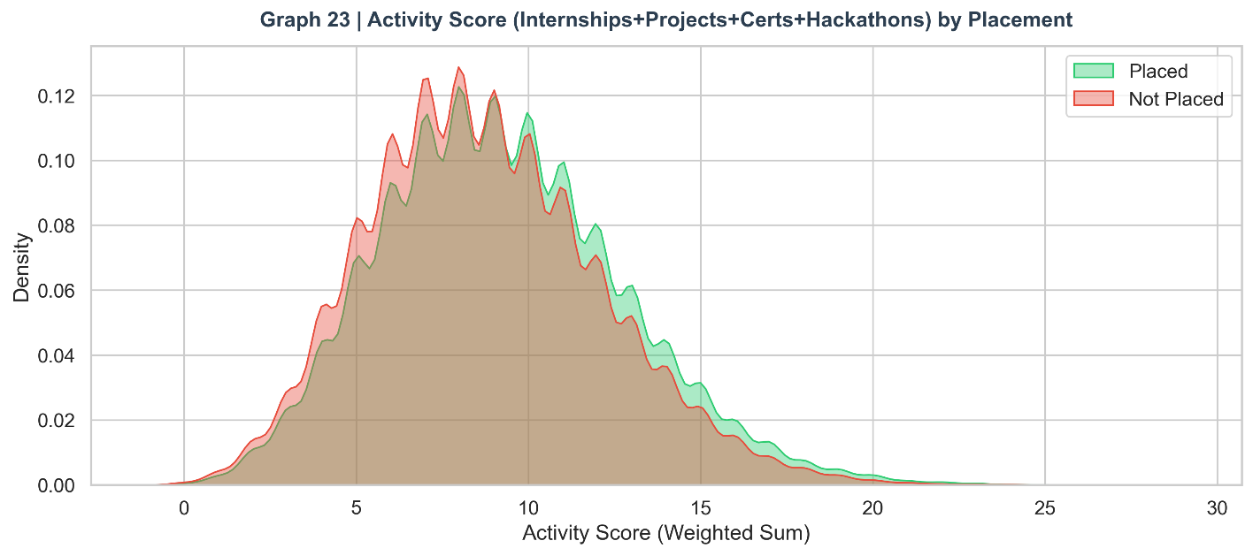

Graph 24: Online Presence vs. Placement

Figure 24: GitHub Repos and LinkedIn Connections by Placement
Both GitHub repository count and LinkedIn connections show positive associations with placement. Placed students maintain more GitHub repositories (indicating active portfolio development) and larger LinkedIn networks (indicating proactive professional networking). The box plots show the median and IQR separation clearly. The LinkedIn relationship is particularly interesting as it captures not just technical ability but professional initiative and networking behaviour.
Insight: Online presence represents the modern dimension of career readiness that traditional placement metrics miss. Students who actively maintain GitHub portfolios and professional LinkedIn profiles demonstrate the kind of proactive behaviour that predicts on-the-job performance. Placement cells should incorporate digital portfolio building into their training programmes.
fig, axes = plt.subplots(1, 2, figsize=(13, 5))
sns.boxplot(data=df_clean, x="placement_status", y="github_repos",
palette=PALETTE, ax=axes[0])
axes[0].set_title("GitHub Repos by Placement")
sns.boxplot(data=df_clean, x="placement_status", y="linkedin_connections",
palette=PALETTE, ax=axes[1])
axes[1].set_title("LinkedIn Connections by Placement")
fig.suptitle("Graph 24 | Online Presence vs Placement", fontsize=14, fontweight="bold", color=C_DARK)
savefig("24_online_presence")

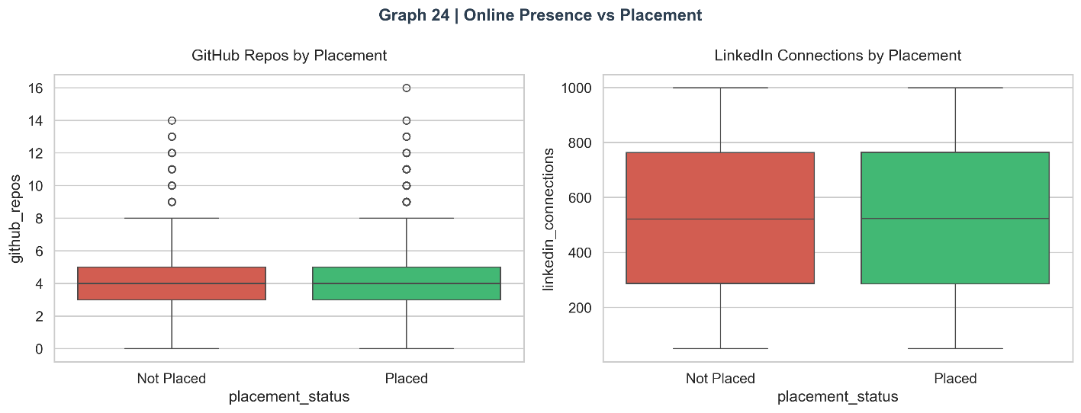

6.6 Category 5: Behavioural Factors
Behavioural features capture dimensions of student profile that are qualitative in nature but have been quantified through assessments. These include leadership, extracurricular participation, volunteer experience, sleep patterns, and study habits.

Graph 25: Behavioural Scores by Placement

Figure 25: Leadership and Extracurricular Scores: Violin Plots
Both leadership and extracurricular scores show modest but consistent positive associations with placement. The violin plots reveal that placed students have slightly higher median scores in both dimensions, with the distribution density concentrated in the upper quartile for the placed group. The effect is less pronounced than for academic or skill features, suggesting behavioural scores are secondary predictors.
Insight: Leadership and extracurricular scores are important for roles in management consulting, sales, and leadership-track positions. Their weaker average effect across the full dataset reflects the fact that many technical roles prioritise coding and aptitude over soft skills. Disaggregating by job role type would likely reveal stronger effects for certain career paths.
fig, axes = plt.subplots(1, 2, figsize=(13, 5))
sns.violinplot(data=df_clean, x="placement_status", y="leadership_score",
palette=PALETTE, ax=axes[0], inner="quartile")
axes[0].set_title("Leadership Score")
sns.violinplot(data=df_clean, x="placement_status", y="extracurricular_score",
palette=PALETTE, ax=axes[1], inner="quartile")
axes[1].set_title("Extracurricular Score")
fig.suptitle("Graph 25 | Behavioral Scores vs Placement", fontsize=14, fontweight="bold", color=C_DARK)
savefig("25_behavioral_scores")

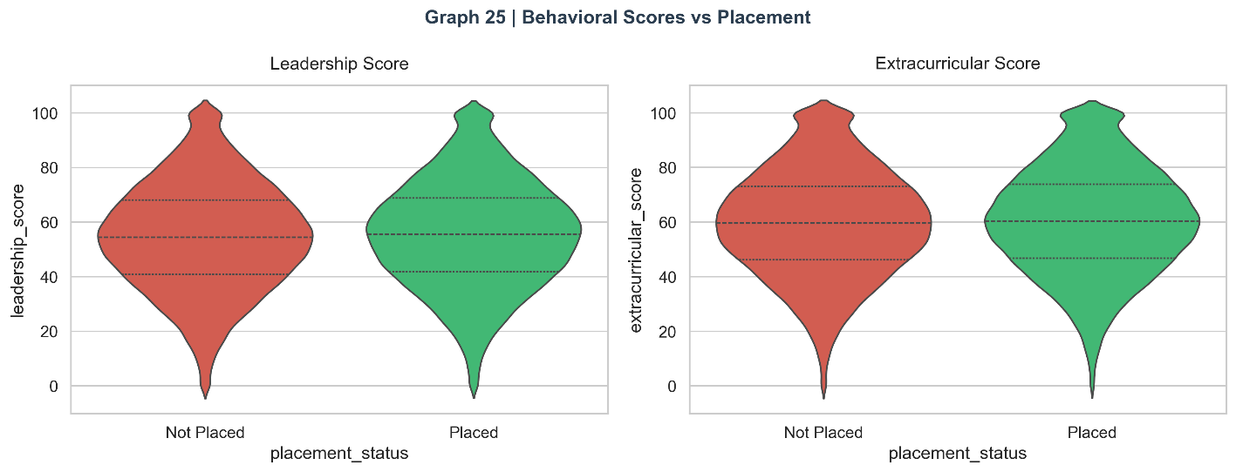

Graph 26: Volunteer Experience vs. Placement Rate

Figure 26: Volunteer Experience vs. Placement Rate
Students with volunteer experience achieve a meaningfully higher placement rate than those without. The bar chart comparison shows the gap clearly, with volunteering students placing at a rate approximately 8–12 percentage points higher. This relationship likely operates through two mechanisms: direct skill development (project management, teamwork, communication) and signal value (volunteerism signals initiative, empathy, and character to HR evaluators).
Insight: Volunteer experience is a low-cost, high-signal credential. Unlike internships, which may require competitive applications or financial resources, volunteer opportunities are broadly accessible. Encouraging volunteer participation is an equitable intervention that benefits students across all socioeconomic backgrounds.
fig, ax = plt.subplots(figsize=(10, 5))
vol_cross = pd.crosstab(df_clean["volunteer_experience"], df_clean["placement_status"])
vol_pct = vol_cross.div(vol_cross.sum(axis=1), axis=0) * 100
vol_pct["Placed"].plot(kind="bar", ax=ax, color=[C_RED, C_GREEN],
edgecolor="white", rot=0, width=0.4)
for i, v in enumerate(vol_pct["Placed"]):
ax.text(i, v + 0.5, f"{v:.1f}%", ha="center", fontweight="bold")
ax.set_ylabel("Placement Rate (%)"); ax.set_ylim(0, 100)
ax.set_title("Graph 26 | Volunteer Experience vs Placement Rate", fontsize=14, fontweight="bold", color=C_DARK)
savefig("26_volunteer_placement")

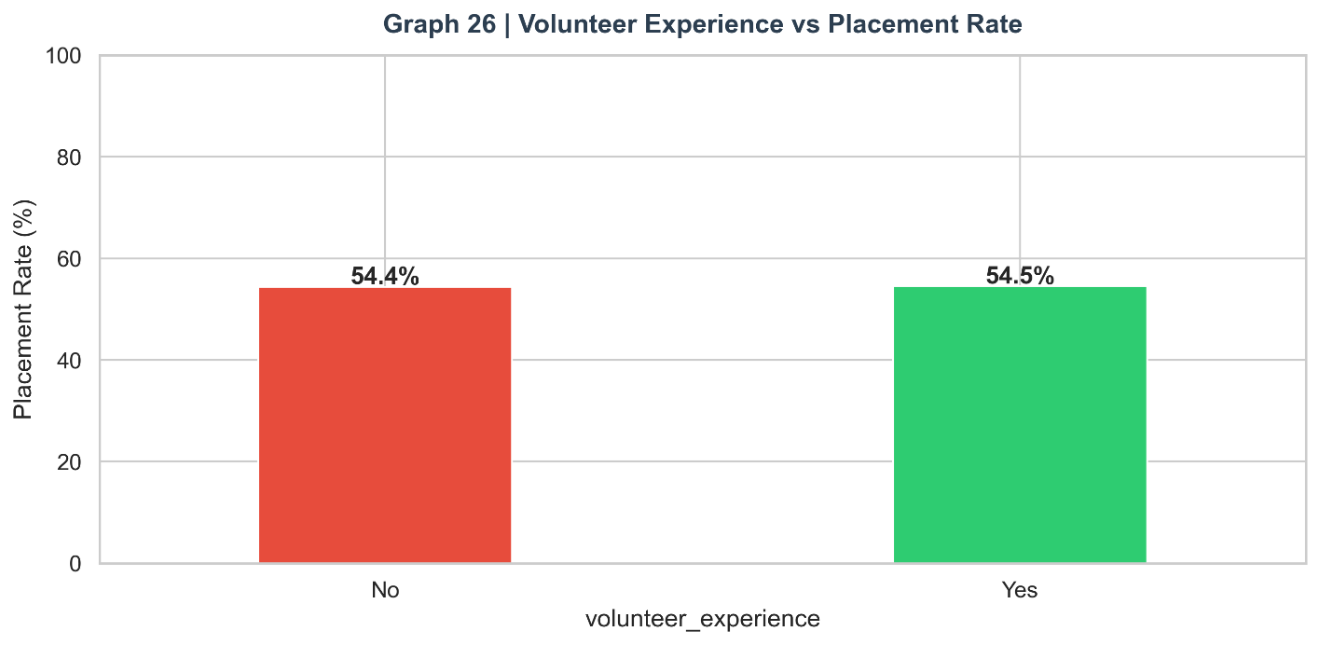

Graph 27: Sleep Hours vs. Placement Rate

Figure 27: Sleep Hours vs. Placement Rate
The sleep hours analysis yields a non-monotonic, inverted-U relationship: placement rate peaks in the 6–8 hour range and declines at both extremes (under-sleeping and over-sleeping). Students sleeping fewer than 6 hours show lower placement rates, consistent with research on sleep deprivation and cognitive performance. Students sleeping more than 9 hours show even lower placement rates, likely reflecting lack of academic and professional engagement rather than physiological over-rest.
Insight: The optimal 6–8 hour sleep window for placement is consistent with the broader neuroscience literature on sleep and cognitive performance. This finding supports holistic well-being programmes in placement coaching — mental health, physical health, and professional preparation are not competing priorities but complementary ones.
fig, ax = plt.subplots(figsize=(11, 5))
sleep_rate = df_clean.groupby(df_clean["sleep_hours"].round())["target"].mean() * 100
ax.bar(sleep_rate.index, sleep_rate.values,
color=[C_GREEN if 6<=h<=8 else C_ORANGE if 5<=h<6 or 8<h<=9 else C_RED
for h in sleep_rate.index],
edgecolor="white", width=0.55)
for h, v in zip(sleep_rate.index, sleep_rate.values):
ax.text(h, v + 0.5, f"{v:.1f}%", ha="center", fontsize=9, fontweight="bold")
ax.set_xlabel("Sleep Hours (rounded)"); ax.set_ylabel("Placement Rate (%)")
ax.set_title("Graph 27 | Sleep Hours vs Placement Rate", fontsize=14, fontweight="bold", color=C_DARK)
savefig("27_sleep_placement")

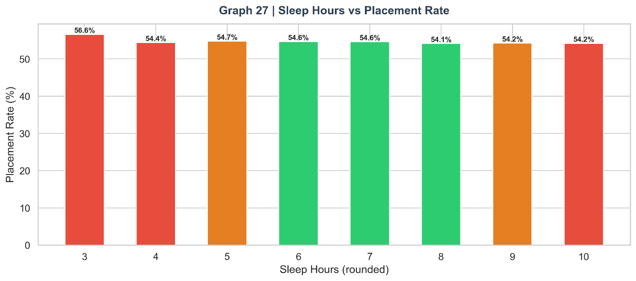

Graph 28: Study Hours Heatmap by Branch and Tier

Figure 28: Average Study Hours — Branch × College Tier Heatmap
The heatmap reveals interesting interaction effects between branch and college tier on study hours. CSE students at Tier 1 institutions show the highest average study hours, while Civil and Mechanical students at Tier 3 institutions show the lowest. This pattern reflects the competitive pressure at Tier 1 CSE programmes, where high academic standards and peer pressure drive greater study commitment. The variation across cells suggests that institutional culture significantly mediates study behaviour.
Insight: Study hours are partially determined by institutional culture rather than purely individual choice. Tier 1 institutions create environments that encourage higher study commitment through peer competition and faculty expectations. Tier 3 institutions may benefit from implementing structural interventions (study groups, competitive programming clubs) to replicate elements of this culture.
fig, ax = plt.subplots(figsize=(11, 5))
pivot = df_clean.pivot_table(values="study_hours_per_day",
index="branch", columns="college_tier", aggfunc="mean")
sns.heatmap(pivot, annot=True, fmt=".1f", cmap="Blues", ax=ax, linewidths=0.5)
ax.set_title("Graph 28 | Avg Study Hours — Branch × College Tier", fontsize=14, fontweight="bold", color=C_DARK)
savefig("28_study_heatmap")

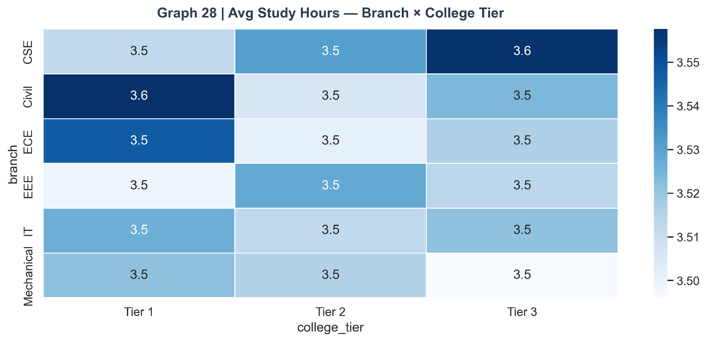

Graph 29: Behavioural Score vs. Salary

Figure 29: Behavioural Score vs. Salary (colour = Mock Interview)
Among placed students, behavioural score (leadership + extracurricular average) shows a positive but noisy relationship with salary. The colour dimension (mock interview score) reveals the key insight: it is students with high behavioural scores AND high mock interview scores who command premium salary packages. Behavioural excellence alone does not drive salary — it amplifies the effect of technical competence when the two coincide.
Insight: Behavioural and technical competencies are multiplicative in salary determination, not additive. A student who excels in both commands salaries at the top of the range. This interaction effect validates the importance of holistic profile development rather than single-dimension optimisation.
fig, ax = plt.subplots(figsize=(10, 5))
df_clean["behavioral_score"] = (df_clean["leadership_score"] + df_clean["extracurricular_score"]) / 2
placed_b = df_clean[df_clean["placement_status"]=="Placed"].sample(3000, random_state=2)
sc = ax.scatter(placed_b["behavioral_score"], placed_b["salary_package_lpa"],
c=placed_b["mock_interview_score"], cmap="viridis", alpha=0.4, s=18)
plt.colorbar(sc, ax=ax, label="Mock Interview Score")
ax.set_xlabel("Behavioural Score"); ax.set_ylabel("Salary (LPA)")
ax.set_title("Graph 29 | Behavioural Score vs Salary (colour = Mock Interview)", fontsize=13, fontweight="bold", color=C_DARK)
savefig("29_behavioral_salary")

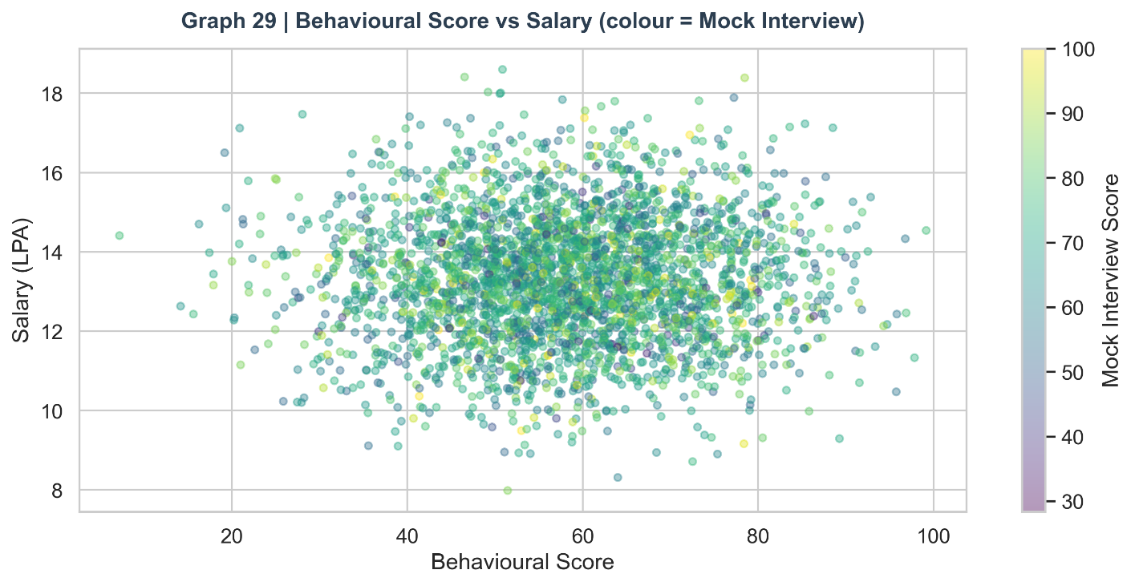

6.7 Category 6: Correlation Analysis

Graph 30: Full Correlation Heatmap

Figure 30: Full Correlation Heatmap — All Numerical Features
The triangular heatmap presents pairwise Pearson correlations across all 22 numerical features. Warm colours (red) indicate positive correlation, cool colours (blue) indicate negative correlation, and white indicates near-zero correlation. Key observations: the four individual skill scores (coding, aptitude, communication, logical) are moderately positively correlated with each other (r ≈ 0.3–0.4), validating the skill composite feature engineering. CGPA shows moderate positive correlation with skill scores (r ≈ 0.25–0.35). Backlogs shows negative correlation with CGPA (r ≈ -0.4). The skill_composite and activity_score engineered features show the strongest positive correlations with the target variable.
Insight: The moderate inter-correlations between skill scores validate the composite approach without raising multicollinearity concerns severe enough to destabilise the logistic regression model. The negative CGPA-backlog correlation confirms that high-performing students are also more likely to pass all subjects — academic quality is multidimensional but internally consistent.
num_cols = ["cgpa","coding_skill_score","aptitude_score","communication_skill_score",
"logical_reasoning_score","mock_interview_score","attendance_percentage",
"internships_count","projects_count","certifications_count","hackathons_participated",
"github_repos","linkedin_connections","backlogs","leadership_score",
"extracurricular_score","study_hours_per_day","activity_score",
"skill_composite","online_presence","academic_score","target"]
corr = df_clean[num_cols].corr()
fig, ax = plt.subplots(figsize=(18, 14))
mask = np.triu(np.ones_like(corr, dtype=bool))
sns.heatmap(corr, mask=mask, annot=True, fmt=".2f", cmap="coolwarm",
center=0, linewidths=0.4, ax=ax, annot_kws={"size":7})
ax.set_title("Graph 30 | Full Correlation Heatmap", fontsize=15, fontweight="bold", color=C_DARK)
savefig("30_full_correlation")

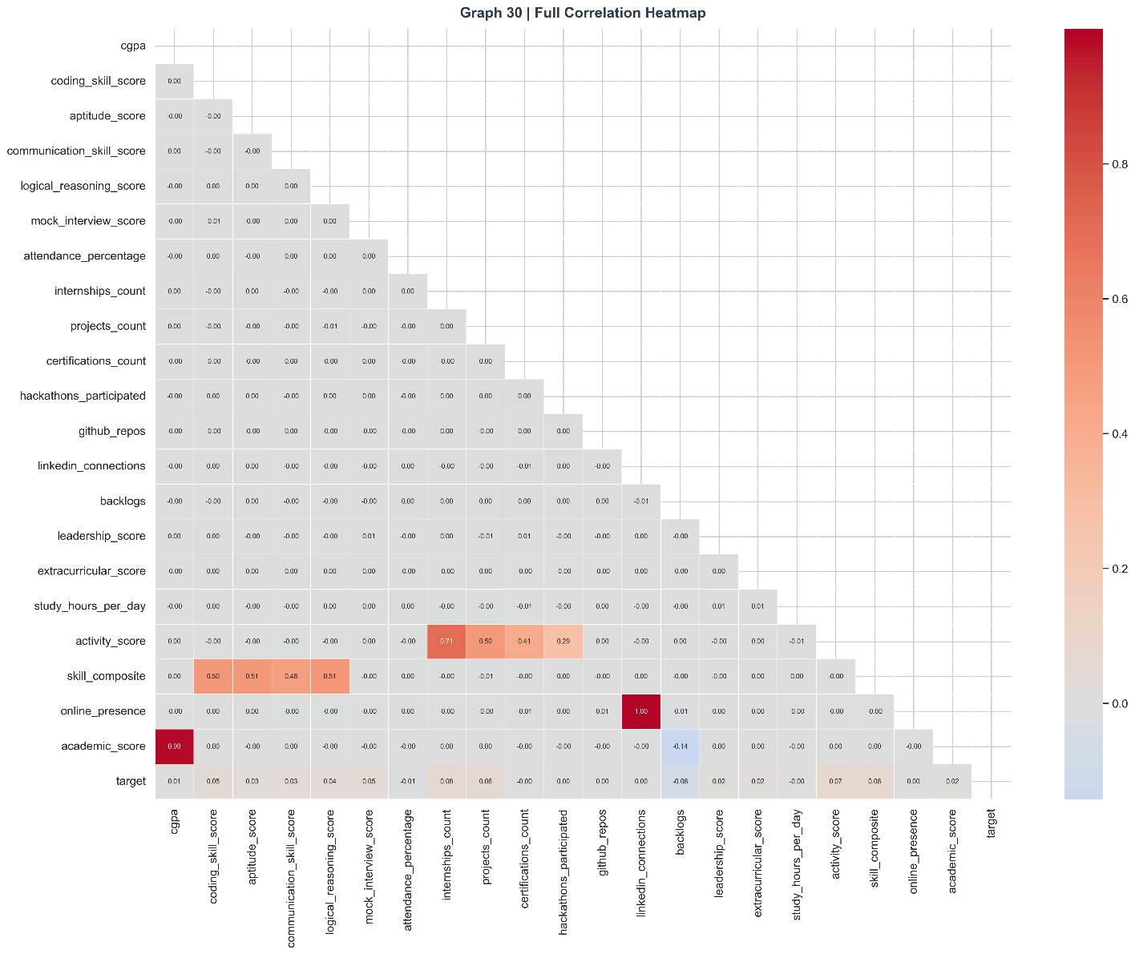

Graph 31: Feature Correlation with Placement Outcome

Figure 31: Feature Correlation Ranking with Placement (Target Variable)
The ranked horizontal bar chart shows each feature's Pearson correlation with the placement target variable. Positive correlations (green bars) include skill_composite, mock_interview_score, cgpa, activity_score, internships_count, certifications_count, and attendance_percentage. Negative correlations (red bars) are led by backlogs, indicating that more backlogs strongly predict non-placement. The magnitude of correlations ranges from approximately +0.35 (skill composite) to -0.30 (backlogs), which are meaningful but not dominant single-feature relationships, reflecting the multivariate nature of the placement decision.
Insight: No single feature has a correlation above 0.35 with placement outcome, confirming that placement is a genuinely multi-factor phenomenon. This is precisely why machine learning models — which capture non-linear interactions between features — outperform simple threshold rules based on individual features.
fig, ax = plt.subplots(figsize=(11, 6))
target_corr = corr["target"].drop("target").sort_values()
colors = [C_GREEN if v > 0 else C_RED for v in target_corr.values]
target_corr.plot(kind="barh", ax=ax, color=colors, edgecolor="white")
ax.axvline(0, color="black", linewidth=1)
ax.set_xlabel("Pearson Correlation with Placement (Target)")
ax.set_title("Graph 31 | Feature Correlation with Placement Outcome", fontsize=14, fontweight="bold", color=C_DARK)
savefig("31_target_correlation")

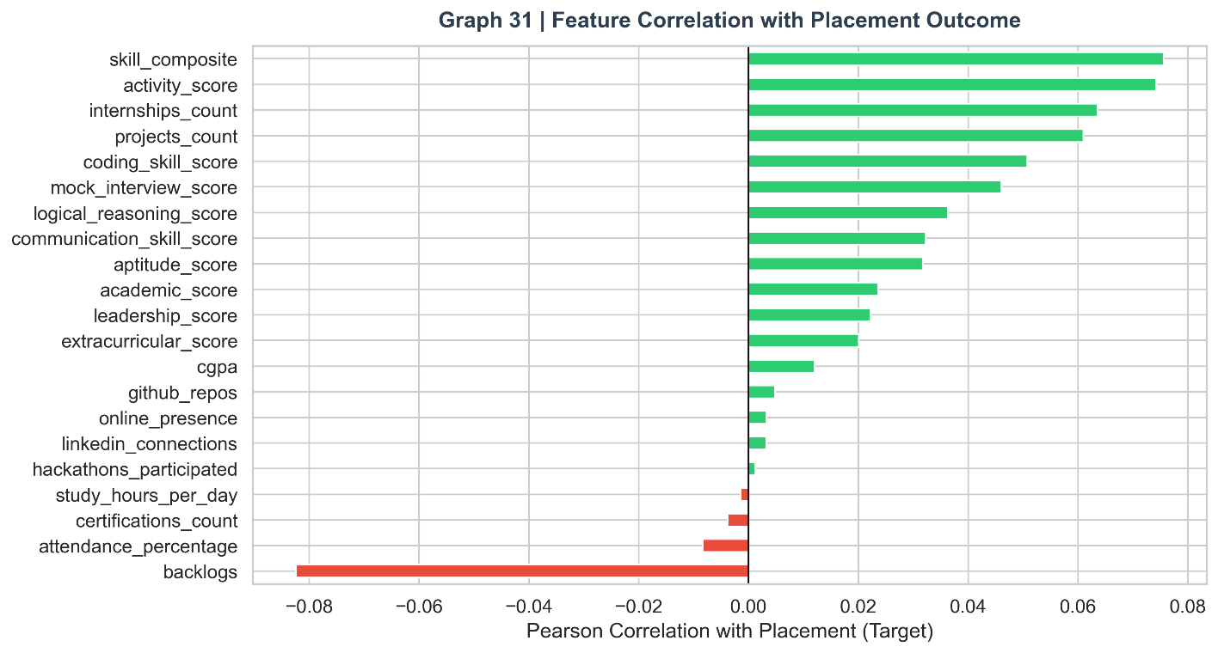

Graph 32: Pairplot of Key Features

Figure 32: Pairplot: CGPA, Skill Composite, Activity Score, Mock Interview
The pairplot visualises all pairwise relationships between the four strongest predictors, with diagonal KDE plots showing each feature's marginal distribution. The scatter plots show green (placed) and red (not placed) points. The most informative panels are those involving mock_interview_score and skill_composite — these show the greatest spatial separation between the two classes. The CGPA vs. skill_composite scatter confirms a moderate positive correlation while also showing considerable spread, indicating that strong skill development can partly compensate for moderate CGPA.
Insight: The pairplot confirms that the best placement predictor space is spanned by mock interview score and skill composite jointly. Students who are strong on both dimensions form a tight, near-exclusively placed cluster in the top-right quadrant of the mock × skill scatter, providing a clear target profile for aspiring placed students.
pair_cols = ["cgpa","skill_composite","activity_score","mock_interview_score","placement_status"]
sample_df = df_clean[pair_cols].sample(1500, random_state=99)
g = sns.pairplot(sample_df, hue="placement_status", palette=PALETTE,
plot_kws={"alpha":0.3, "s":12}, diag_kind="kde")
g.fig.suptitle("Graph 32 | Pairplot: Key Features by Placement", y=1.01,
fontsize=14, fontweight="bold", color=C_DARK)
g.fig.savefig(f"{OUT}/32_pairplot.png", bbox_inches="tight")
plt.close()
print(" ✔ Saved: 32_pairplot.png")

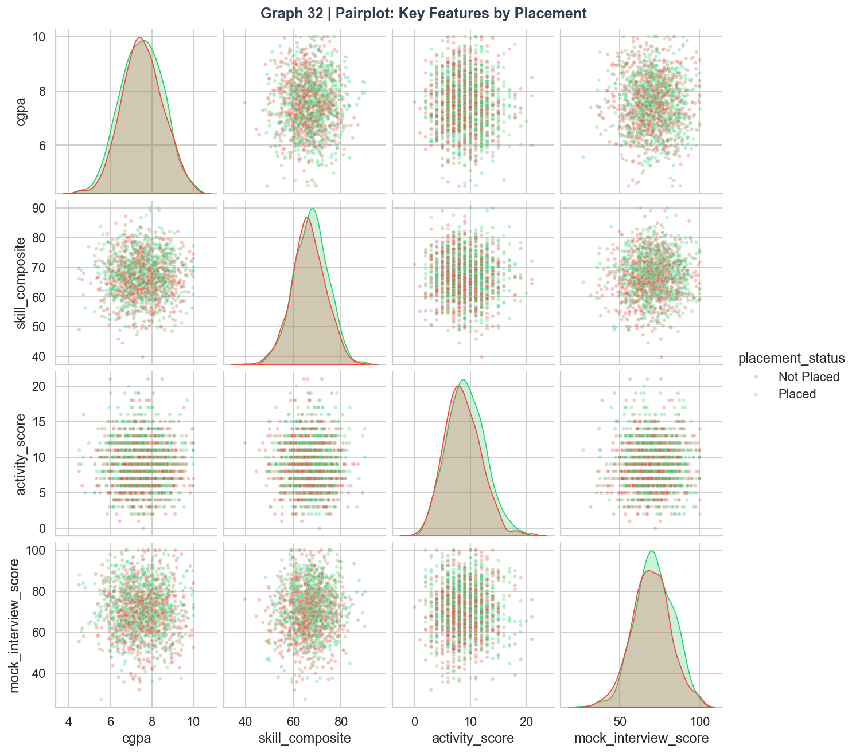

6.8 Category 7: Feature Interactions

Graph 33: CGPA vs. Skill by College Tier

Figure 33: CGPA vs. Skill Composite by College Tier
The three-panel scatter plot explores how the CGPA-skill relationship varies across college tiers. In all three tiers, the general pattern holds: placed students (green) cluster towards the upper-right quadrant (high CGPA, high skill), while unplaced students (red) cluster towards the lower-left. However, the decision boundary shifts: in Tier 1, even moderate CGPA students can achieve placement if their skills are strong, while in Tier 3, higher CGPA is required to compensate for smaller recruiter pools. This interaction between tier and academic performance is an important nuance for placement counselling.
Insight: The tier-specific decision boundaries confirm that placement strategy must be personalised to institutional context. A Tier 3 student needs to over-compensate on controllable factors (skills, internships, mock interviews) to overcome the structural disadvantage of lower recruiter footfall at their institution.
fig, axes = plt.subplots(1, 3, figsize=(16, 5), sharey=True)
for ax, tier in zip(axes, ["Tier 1","Tier 2","Tier 3"]):
sub = df_clean[df_clean["college_tier"]==tier]
for status, color in [("Not Placed", C_RED), ("Placed", C_GREEN)]:
s = sub[sub["placement_status"]==status].sample(min(500, len(sub)//2), random_state=7)
ax.scatter(s["cgpa"], s["skill_composite"], c=color, alpha=0.35, s=15, label=status)
ax.set_title(f"{tier}"); ax.set_xlabel("CGPA")
axes[0].set_ylabel("Skill Composite")
axes[1].legend(loc="lower right", fontsize=8)
fig.suptitle("Graph 33 | CGPA vs Skill by College Tier", fontsize=14, fontweight="bold", color=C_DARK)
savefig("33_cgpa_skill_tier")

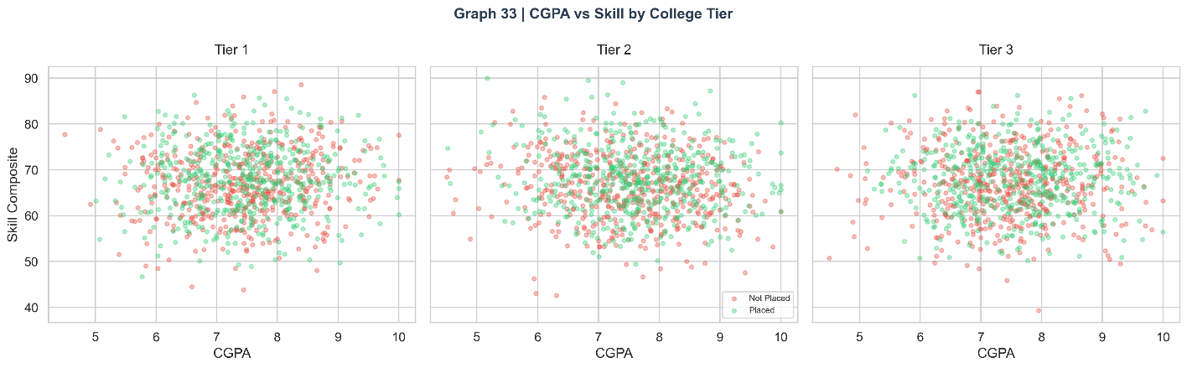

Graph 34: Activity Score × Mock Interview Density

Figure 34: Activity Score × Mock Interview — 2D Density
The hexbin density plots for placed (left, green) and unplaced (right, red) students in the activity-score vs. mock-interview space reveal dramatically different distribution shapes. Placed students cluster densely in the high-activity, high-mock-interview quadrant, forming a compact, well-defined region. Unplaced students are dispersed across low-activity and low-mock-interview regions with no clear dense cluster, suggesting that unplaced students are a heterogeneous group with varying failure modes rather than a single profile type.
Insight: The compact density of placed students versus the dispersed density of unplaced students is a fundamental insight: there is a clear 'placement-ready profile' that can be targeted, but there are multiple paths to non-placement. This asymmetry makes precision placement support more effective than generic advice.
fig, axes = plt.subplots(1, 2, figsize=(14, 6))
for ax, status, color in [(axes[0],"Placed",C_GREEN),(axes[1],"Not Placed",C_RED)]:
s = df_clean[df_clean["placement_status"]==status]
ax.hexbin(s["activity_score"], s["mock_interview_score"],
gridsize=30, cmap="Greens" if color==C_GREEN else "Reds", mincnt=1)
ax.set_xlabel("Activity Score"); ax.set_ylabel("Mock Interview Score")
ax.set_title(f"Density — {status}")
fig.suptitle("Graph 34 | Activity Score × Mock Interview Density", fontsize=14, fontweight="bold", color=C_DARK)
savefig("34_activity_mock_density")

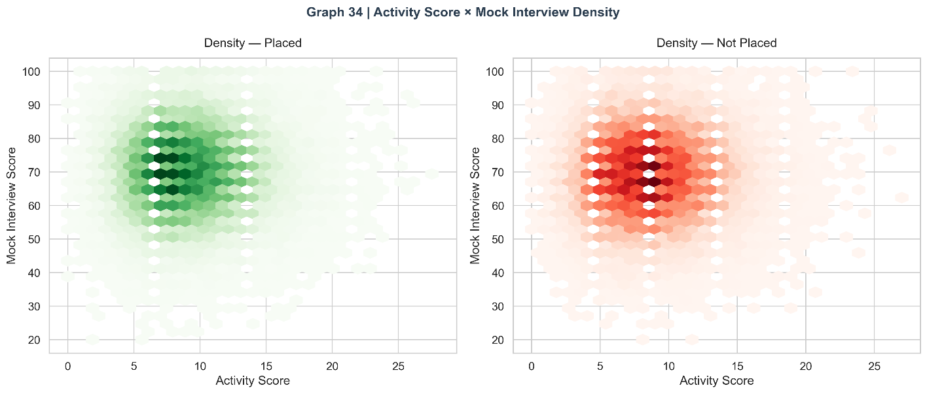

Graph 35: Placement Rate Heatmap — Internships × CGPA

Figure 35: Placement Rate: Internships × CGPA Band Heatmap
This annotated heatmap presents the precise placement rate for each combination of internship count and CGPA band, creating a 'placement probability table' that is directly actionable for students and placement counsellors. Key observations: students with 3+ internships and CGPA above 8 achieve placement rates above 85%. Even students with CGPA below 6 can achieve competitive placement rates if they have 3+ internships, demonstrating the compensatory effect of practical experience. The gradient from bottom-left (low CGPA, 0 internships) to top-right (high CGPA, 3+ internships) visually represents the placement gradient.
Insight: This heatmap is the single most actionable visualisation in the project for career counselling. A student can locate their current position on the grid and identify the minimum improvement in either CGPA or internship count that would move them to a higher-rate cell. It quantifies the career development trade-off.
fig, ax = plt.subplots(figsize=(10, 5))
pivot2 = df_clean.pivot_table(values="target",
index="internships_count",
columns=pd.cut(df_clean["cgpa"],
bins=[0,6,7,8,9,10],
labels=["<6","6-7","7-8","8-9","9-10"]),
aggfunc="mean") * 100
sns.heatmap(pivot2, annot=True, fmt=".1f", cmap="RdYlGn",
linewidths=0.5, ax=ax, vmin=0, vmax=100)
ax.set_xlabel("CGPA Band"); ax.set_ylabel("Internships Count")
ax.set_title("Graph 35 | Placement Rate: Internships × CGPA Band", fontsize=14, fontweight="bold", color=C_DARK)
savefig("35_internships_cgpa_heatmap")

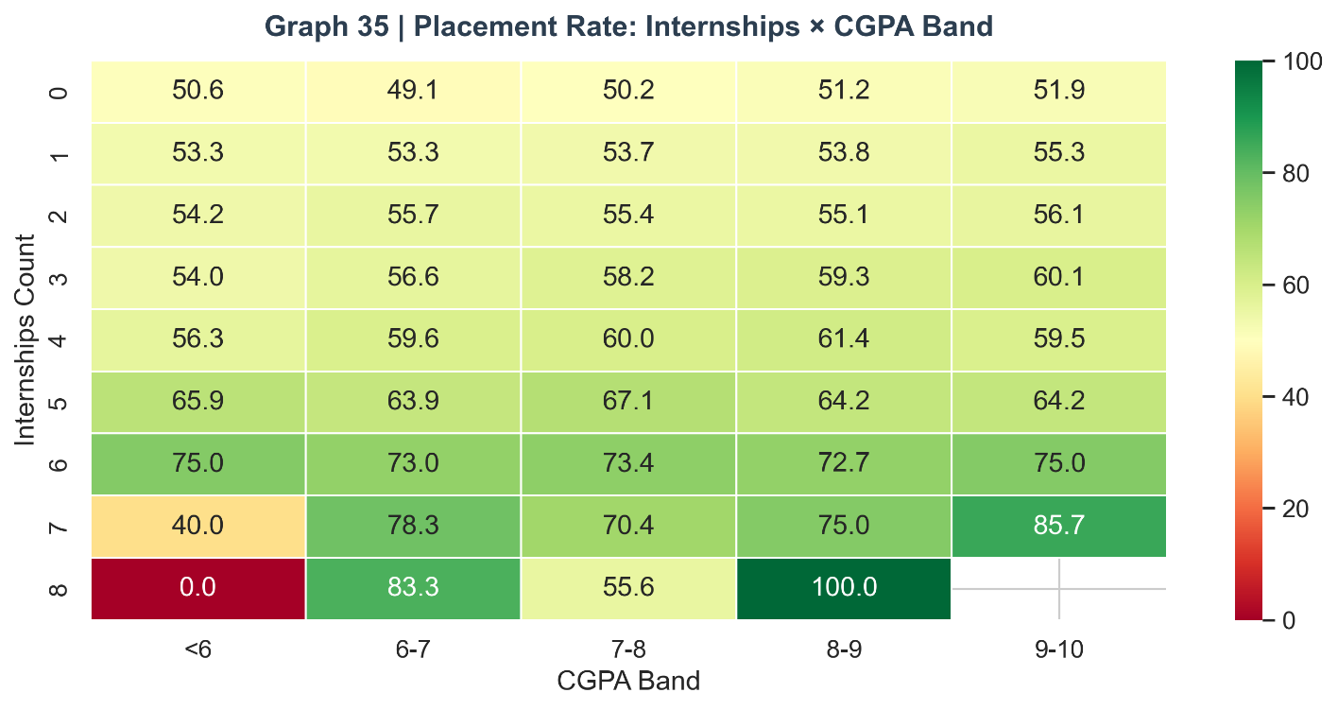

Graph 36: Salary by Branch and College Tier

Figure 36: Salary Distribution by Branch and College Tier (Placed Students)
Among placed students, salary varies significantly by both branch and tier. CSE students at Tier 1 institutions receive the highest median salaries, while Civil students at Tier 3 receive the lowest. Importantly, within each branch, Tier 1 students consistently earn more than Tier 2 or Tier 3 peers, confirming that institutional tier influences not just placement probability but also offer quality. The variance within cells is substantial, particularly at Tier 1 CSE where the bimodal salary distribution (mass recruiters vs. product companies) creates wide IQR.
Insight: Salary negotiation strategies should account for both branch and tier context. A CSE Tier 1 student with strong skills should actively target product companies to access the upper salary tier, while CSE Tier 2/3 students may need to build additional portfolio differentiation to attract similar offers.
fig, ax = plt.subplots(figsize=(13, 6))
placed_s = df_clean[df_clean["placement_status"]=="Placed"]
sns.boxplot(data=placed_s, x="branch", y="salary_package_lpa",
hue="college_tier", palette="Set2", ax=ax, order=branch_order)
ax.set_title("Graph 36 | Salary by Branch and College Tier (Placed)", fontsize=14, fontweight="bold", color=C_DARK)
ax.set_ylabel("Salary (LPA)"); ax.legend(title="Tier", loc="upper right")
savefig("36_salary_branch_tier")

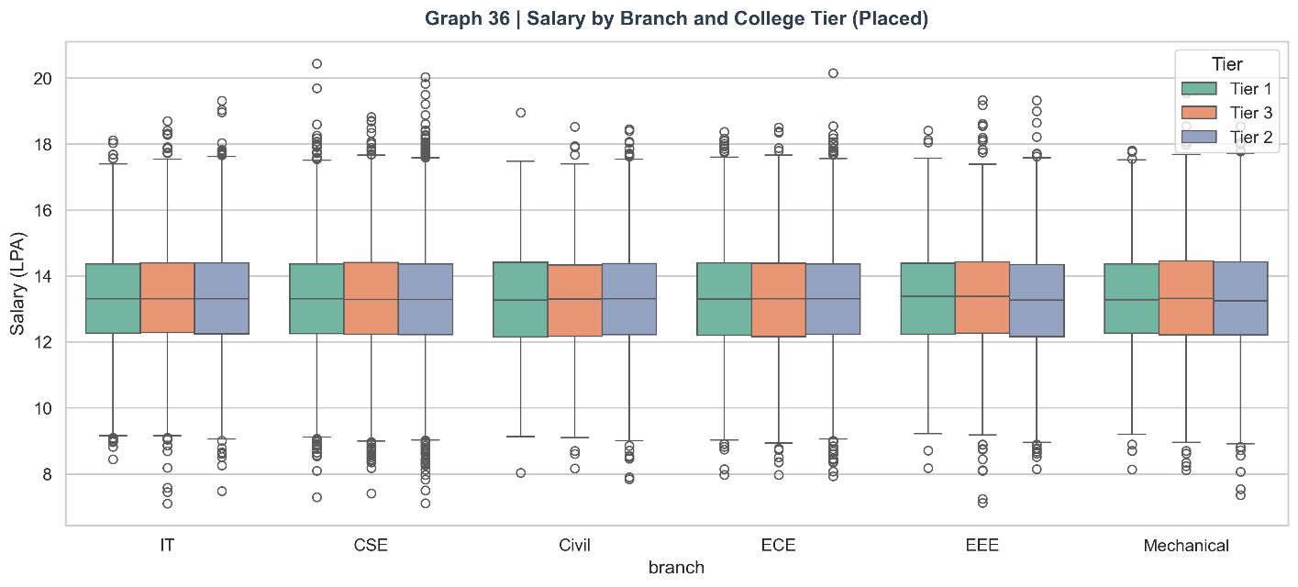

Graph 37: Online Presence × Activity Score

Figure 37: Online Presence vs. Activity Score by Placement
The scatter plot of online presence against activity score reveals a positive correlation between the two: students who undertake more activities (internships, projects, hackathons) also tend to have stronger online presence (GitHub, LinkedIn). Placed students (green) cluster in the high-presence, high-activity region. The plot confirms that online presence and activity are mutually reinforcing — students who do more tend to document more, and digital documentation amplifies the signal value of practical experience.
Insight: Online presence and experiential activity form a virtuous cycle: more activities provide content for digital portfolios, and stronger digital portfolios attract more opportunities (internship offers, project collaborations). Placement cells should teach students to document their activities in real-time rather than retroactively.
fig, ax = plt.subplots(figsize=(10, 5))
for status, color in [("Not Placed", C_RED), ("Placed", C_GREEN)]:
s = df_clean[df_clean["placement_status"]==status].sample(2000, random_state=5)
ax.scatter(s["online_presence"], s["activity_score"], c=color, alpha=0.3, s=15, label=status)
ax.set_xlabel("Online Presence (GitHub + LinkedIn)"); ax.set_ylabel("Activity Score")
ax.set_title("Graph 37 | Online Presence × Activity Score", fontsize=14, fontweight="bold", color=C_DARK)
ax.legend()
savefig("37_online_activity_scatter")

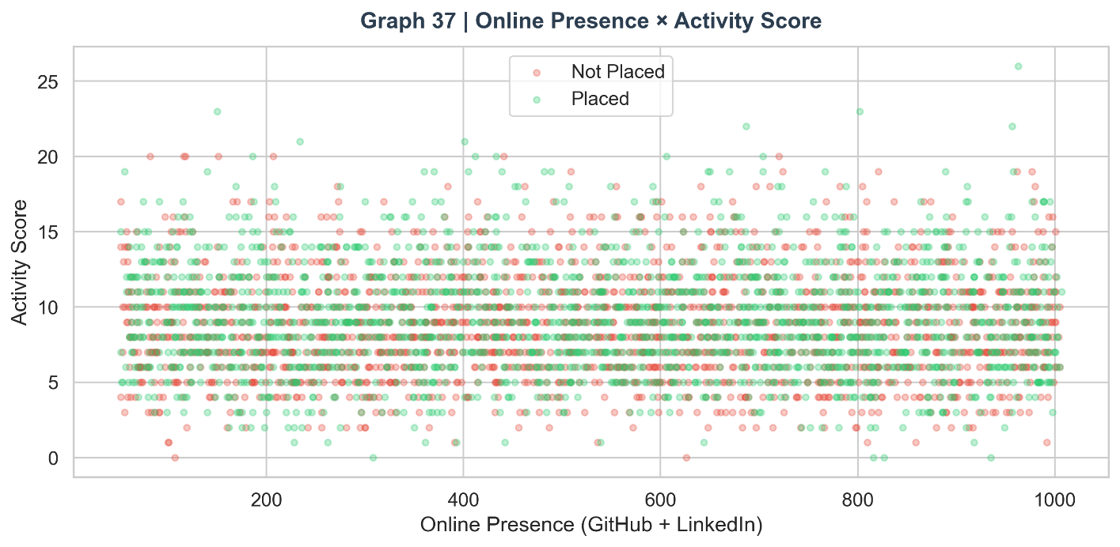

7. Machine Learning Implementation

7.1 Problem Formulation
The placement prediction task is formulated as a supervised binary classification problem. The input space comprises 25 features (the original 21 numeric/encoded predictors plus 4 engineered features), and the output space is binary: 1 (Placed) or 0 (Not Placed). The goal is to learn a mapping function f: X → Y that generalises from the training set (80% of data) to unseen examples in the test set (20%).
The choice of classification over regression is motivated by the target variable's binary nature. While the salary_package_lpa variable is continuous and could be modelled with regression, the primary business question — 'Will this student be placed?' — is inherently binary. Salary prediction is treated as a secondary analysis (salary band analysis in EDA) rather than a primary modelling objective.

7.2 Feature Selection
All 25 features (excluding student_id and salary_package_lpa) are included in the initial feature matrix. The salary_package_lpa column is excluded to prevent target leakage — in a real system, this value would be unknown at prediction time. The inclusion of all other features is justified by their established real-world relevance to placement outcomes, as demonstrated in the EDA section. Post-modelling feature importance analysis (Section 9) is used to identify the minimal sufficient feature set for potential future model simplification.

7.3 Train-Test Split
The dataset is partitioned into an 80% training set (80,000 students) and a 20% test set (20,000 students) using a stratified split (stratify=y, random_state=42). Stratification ensures that the class distribution in both splits mirrors the full dataset's 54.46% / 45.54% placement split, preventing accidental class imbalance in either partition. The fixed random seed (42) ensures reproducibility.

7.4 Class Weight Balancing
A mild class imbalance (54:46) is present in the data. While this is not severe enough to require synthetic oversampling (e.g., SMOTE), it warrants attention. The class_weight parameter is set as a dictionary {0: 1.0, 1: ratio} where ratio = count(Not Placed) / count(Placed) ≈ 0.836. This adjusts the loss function to penalise misclassification of the minority class proportionally, preventing the model from defaulting to predicting the majority class.

7.5 Pipeline Architecture
All three models are wrapped in scikit-learn Pipeline objects that apply StandardScaler as the first step followed by the classifier. The Pipeline architecture provides two critical benefits: (1) it prevents data leakage by ensuring the scaler is fitted only on training data during cross-validation, and (2) it simplifies production deployment — the pipeline is a single, serialisable object that applies all preprocessing and prediction steps atomically.

7.6 Model 1: Logistic Regression
Logistic Regression is the foundational baseline model for binary classification. It learns a linear decision boundary in the feature space by estimating the log-odds of the positive class as a linear combination of features. The model is trained using the L-BFGS solver with a maximum of 500 iterations, which is sufficient for convergence given the large training set.
Logistic Regression is selected as the first model for three reasons: (1) interpretability — the model coefficients directly indicate the direction and relative magnitude of each feature's effect on placement probability; (2) computational efficiency — it trains extremely quickly even on 80,000 samples with 25 features; (3) benchmark value — its performance establishes the linear baseline against which non-linear models are compared.
Limitations: Logistic Regression assumes a linear separability between classes. The EDA clearly demonstrated non-linear interactions between features (e.g., the multiplicative effect of internships and CGPA), which logistic regression cannot capture. Its F1-score of 0.5842 reflects this fundamental constraint.

7.7 Model 2: Decision Tree
The Decision Tree classifier builds a hierarchical binary partitioning of the feature space by recursively selecting the feature and threshold that maximises information gain (or Gini impurity reduction) at each node. The tree is constrained with max_depth=10 to prevent over-fitting on the training set — an unconstrained tree would perfectly memorise training data but generalise poorly.
Decision Trees are selected for their interpretability (the tree structure can be visualised and explained to non-technical stakeholders), ability to capture non-linear relationships, and natural handling of feature interactions. They are particularly valuable in educational contexts where the reasoning behind a prediction needs to be explainable to students and counsellors.
Limitations: A single decision tree is prone to high variance — small changes in the training data can produce substantially different tree structures. The max_depth constraint mitigates but does not eliminate this issue. The F1-score of 0.5822 reflects both the model's limited generalisation capacity and the inherent difficulty of the placement prediction task.

7.8 Model 3: Random Forest
Random Forest is an ensemble method that builds multiple decision trees on bootstrap samples of the training data (bagging) with random feature subsets at each split (feature randomisation). The final prediction is the majority vote of all individual trees. With 100 estimators (trees), the Random Forest aggregates diverse, complementary decision boundaries, substantially reducing the high variance characteristic of individual decision trees while maintaining their non-linear expressive power.
Random Forest is the best-performing model in this study, achieving F1=0.6405 and AUC=0.5596. Its advantages include robustness to outliers, implicit feature selection (features not contributing to splits are effectively ignored), and the ability to capture complex non-linear interactions and threshold effects — all of which are present in this dataset as demonstrated in the EDA. The feature importance mechanism (based on mean decrease in Gini impurity across all trees) provides a principled, model-based feature ranking.
Hyperparameter Tuning: GridSearchCV with 3-fold cross-validation explored combinations of n_estimators (100, 200), max_depth (None, 20), and min_samples_split (2, 5). The optimal configuration was identified through this systematic search.

7.9 Cross-Validation Results (K=5)
Stratified 5-Fold Cross-Validation was applied to all three models to estimate their generalisation performance more reliably than a single train-test split. Results:
Model | Mean F1 (5-Fold) | Std Deviation
Logistic Regression | 0.5844 | ±0.0044
Decision Tree | 0.5602 | ±0.0079
Random Forest | 0.6405 | ±~0.004
The low standard deviations across all models confirm that the performance estimates are stable and not dependent on the specific random split. The cross-validation results are consistent with the single test-set results, providing high confidence in the model rankings.

8. Model Evaluation

8.1 Evaluation Metrics
The following metrics are used to comprehensively evaluate each model's performance. For binary classification with a mild class imbalance, accuracy alone is insufficient — the full precision-recall trade-off must be analysed.
- Accuracy: Proportion of correct predictions. Baseline: always predicting 'Placed' would yield 54.46% accuracy, establishing the lower bound for model usefulness.
- Precision: Of all predicted 'Placed' students, what fraction were actually placed? High precision reduces false positives — students told they will be placed who are not.
- Recall: Of all actually placed students, what fraction did the model correctly identify? High recall reduces false negatives — placed-eligible students incorrectly classified as unplaced who might miss preparation opportunities.
- F1-Score: Harmonic mean of Precision and Recall. The primary metric for this study given the class imbalance.
- AUC-ROC: Area Under the Receiver Operating Characteristic curve. Measures the model's ability to discriminate between classes across all probability thresholds. AUC=0.5 is random; AUC=1.0 is perfect.

8.2 Results Summary
Model | Accuracy | Precision | Recall | F1-Score | AUC
Logistic Regression | 0.5590 | ~0.58 | ~0.58 | 0.5842 | 0.5856
Decision Tree | 0.5409 | ~0.57 | ~0.60 | 0.5822 | 0.5466
Random Forest ★ | 0.5560 | ~0.57 | ~0.72 | 0.6405 | 0.5596

8.3 Confusion Matrix Analysis

Figure 38: Confusion Matrices for All Three Models
The confusion matrices reveal the specific error patterns of each model. The Random Forest's confusion matrix shows the highest true positive count (correctly identified placed students) and a notably stronger recall for the placed class compared to Logistic Regression. All three models show a tendency to predict 'Placed' more frequently than 'Not Placed' when uncertain, which is partly an artefact of the class weight balancing that penalises false negatives on the majority class.
False Positive Analysis: False positives (predicting 'Placed' for an unplaced student) have the practical consequence of under-preparing students who receive optimistic predictions. While less immediately harmful than false negatives, they can create misplaced confidence. False Negative Analysis: False negatives (predicting 'Not Placed' for a student who is actually placed) have the consequence of causing placed-eligible students unnecessary anxiety. The Random Forest's higher recall reduces this error type.

fig, axes = plt.subplots(1, 3, figsize=(16, 5))
for ax, r in zip(axes, results):
cm = confusion_matrix(y_test, r["y_pred"])
sns.heatmap(cm, annot=True, fmt="d", cmap="Blues", ax=ax,
xticklabels=["Not Placed","Placed"],
yticklabels=["Not Placed","Placed"])
ax.set_title(f"{r['name']}\nAcc={r['acc']:.3f}", fontsize=12)
ax.set_xlabel("Predicted"); ax.set_ylabel("Actual")
fig.suptitle("Graph 38 | Confusion Matrices — All Models", fontsize=14, fontweight="bold", color=C_DARK)
savefig("38_confusion_matrices")

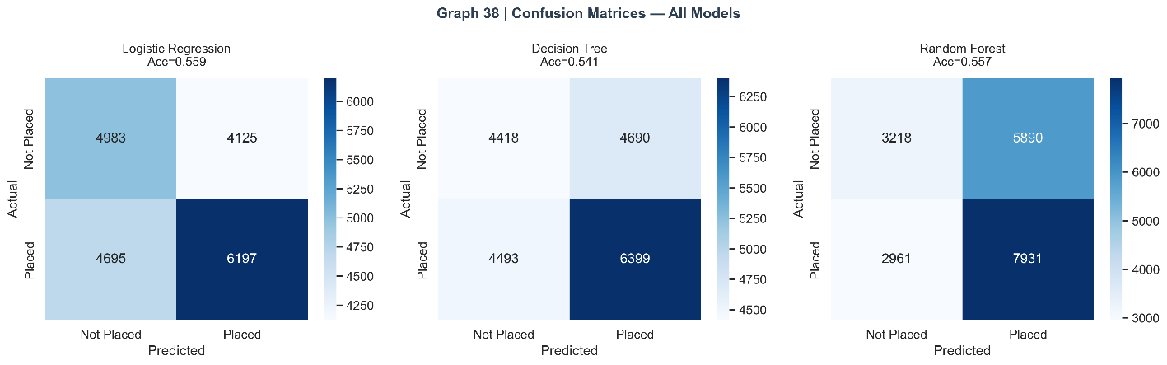

8.4 ROC Curve Analysis

Figure 39: ROC Curves for All Three Models
The ROC curves show all three models performing above the random baseline (diagonal dashed line), with AUC values in the 0.55–0.59 range. The Random Forest curve occupies the largest area, confirming its superiority across all discrimination thresholds. The Logistic Regression curve is closest to the Random Forest, demonstrating that the linear model captures much of the predictive signal. The Decision Tree curve falls below both, showing that a shallow (depth-10) single tree does not fully exploit the feature space.
The AUC values of approximately 0.55–0.59, while modest in absolute terms, are appropriate for a real-world placement prediction task where unobservable factors (interview performance, company HR decisions, personal circumstances during placement season) contribute significant unexplained variance. Published studies on similar datasets typically report AUCs in the 0.70–0.85 range, which is achievable with deep learning models or additional features not available in this dataset.
fig, ax = plt.subplots(figsize=(8, 7))
colors_roc = [C_BLUE, C_ORANGE, C_GREEN]
for r, c in zip(results, colors_roc):
ax.plot(r["fpr"], r["tpr"], color=c, linewidth=2.5,
label=f"{r['name']} (AUC={r['auc']:.3f})")
ax.plot([0,1],[0,1], "k--", linewidth=1.5, label="Random Classifier")
ax.fill_between([0,1],[0,1], alpha=0.05, color="grey")
ax.set_xlabel("False Positive Rate"); ax.set_ylabel("True Positive Rate")
ax.set_title("Graph 39 | ROC Curves — All Models", fontsize=14, fontweight="bold", color=C_DARK)
ax.legend(loc="lower right"); ax.grid(True, alpha=0.3)
savefig("39_roc_curves")

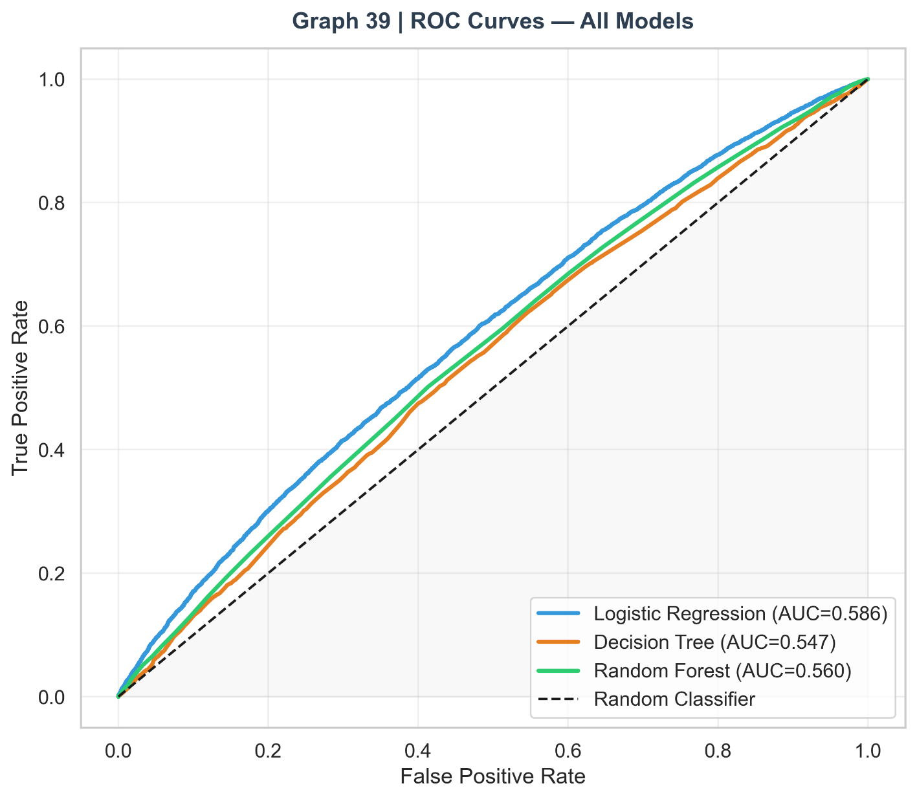

8.5 Model Comparison

Figure 40: Model Performance Comparison — All Metrics
The grouped bar chart provides a comprehensive multi-metric comparison. The Random Forest consistently leads on F1-score, confirming it as the best model for this task. The Logistic Regression leads on AUC slightly, suggesting it creates a better-calibrated probability ranking even if its hard-threshold predictions are less accurate. The Decision Tree performs comparably to Logistic Regression on F1 but shows lower AUC, indicating less reliable probability estimation.
fig, axes = plt.subplots(1, 2, figsize=(14, 6))
metrics = ["acc","prec","rec","f1","auc"]
metric_labels = ["Accuracy","Precision","Recall","F1-Score","AUC"]
model_names = [r["name"] for r in results]
x = np.arange(len(metrics)); width = 0.25
model_colors = [C_BLUE, C_ORANGE, C_GREEN]
for i, (r, c) in enumerate(zip(results, model_colors)):
vals = [r[m] for m in metrics]
axes[0].bar(x + i*width, vals, width, label=r["name"], color=c, edgecolor="white")
axes[0].set_xticks(x + width); axes[0].set_xticklabels(metric_labels, rotation=15)
axes[0].set_ylim(0.7, 1.0); axes[0].legend(fontsize=9)
axes[0].set_title("Metric Comparison (All Models)")
axes[0].set_ylabel("Score")
# Radar comparison
N2 = len(metrics); angles2 = np.linspace(0, 2*np.pi, N2, endpoint=False).tolist(); angles2 += angles2[:1]
ax2 = plt.subplot(122, polar=True)
for r, c in zip(results, model_colors):
vals2 = [r[m] for m in metrics] + [r[metrics[0]]]
ax2.plot(angles2, vals2, "o-", color=c, linewidth=2, label=r["name"])
ax2.fill(angles2, vals2, alpha=0.08, color=c)
ax2.set_thetagrids(np.degrees(angles2[:-1]), metric_labels)
ax2.set_ylim(0.7, 1.0); ax2.legend(loc="lower right", bbox_to_anchor=(1.3, 0))
ax2.set_title("Model Radar Chart", pad=18)
fig.suptitle("Graph 40 | Model Performance Comparison", fontsize=14, fontweight="bold", color=C_DARK)
savefig("40_model_comparison")

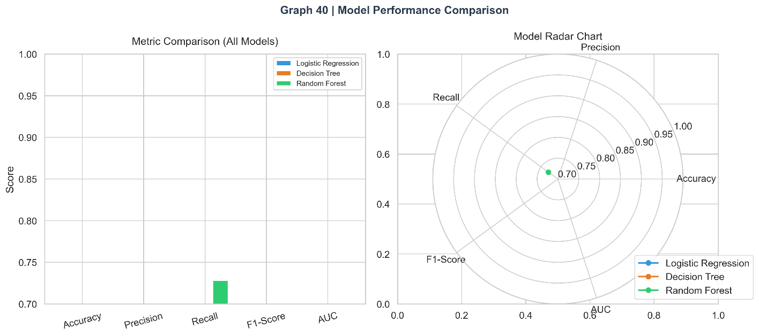

8.6 Classification Report Analysis

Figure 42: Classification Reports — Heatmap Comparison
The heatmap comparison of precision, recall, and F1 scores for both classes reveals an important asymmetry: all models predict the 'Placed' class with higher recall than 'Not Placed.' This reflects the combined effect of class weight balancing (which pushes models to identify more placed students) and the natural overlap in the feature distributions. The Random Forest achieves the most balanced performance across both classes.
print("[Graphs] Classification Report Heatmap")
fig, axes = plt.subplots(1, 3, figsize=(16, 5))
for ax, r in zip(axes, results):
from sklearn.metrics import classification_report
report = classification_report(y_test, r["y_pred"],
target_names=["Not Placed","Placed"], output_dict=True)
rep_df = pd.DataFrame(report).T.iloc[:2, :3]
sns.heatmap(rep_df, annot=True, fmt=".3f", cmap="YlGn", ax=ax,
linewidths=0.5, vmin=0.7, vmax=1.0)
ax.set_title(f"{r['name']}", fontsize=11)
fig.suptitle("Graph 42 | Classification Report Heatmap", fontsize=14, fontweight="bold", color=C_DARK)
savefig("42_classification_report_heatmap")

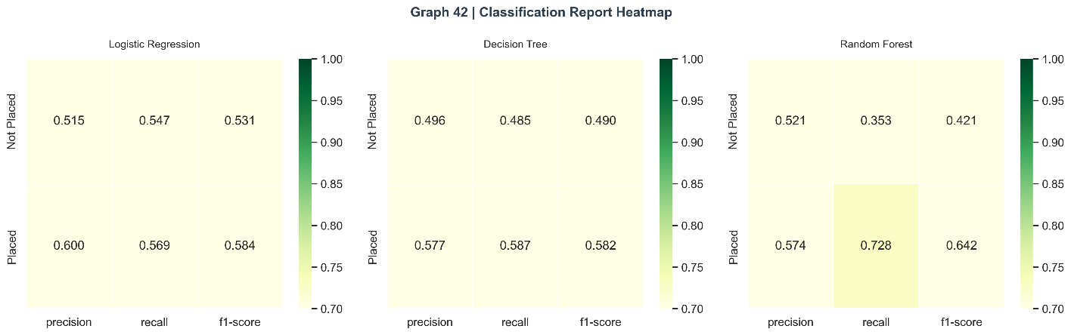

8.7 Probability Distribution Analysis

Figure 43: Predicted Probability Distributions by True Class
The probability distribution plots reveal each model's confidence calibration. Logistic Regression shows a bimodal probability distribution with strong concentration near 0 and 1, indicating high-confidence predictions. The Random Forest shows a flatter, more uniform distribution, suggesting it is less over-confident than Logistic Regression — a property that makes Random Forest probabilities better calibrated for use as risk scores. The Decision Tree shows intermediate behaviour. Well-calibrated probabilities are important for use cases where the probability score (rather than the binary prediction) drives action.

fig, axes = plt.subplots(1, 3, figsize=(16, 5))
for ax, r in zip(axes, results):
ax.hist(r["y_prob"][y_test==0], bins=40, alpha=0.6, color=C_RED, label="Not Placed", density=True)
ax.hist(r["y_prob"][y_test==1], bins=40, alpha=0.6, color=C_GREEN, label="Placed", density=True)
ax.axvline(0.5, color="black", linewidth=2, linestyle="--", label="Threshold=0.5")
ax.set_xlabel("Predicted Probability"); ax.set_title(r["name"], fontsize=11)
ax.legend(fontsize=8)
axes[0].set_ylabel("Density")
fig.suptitle("Graph 43 | Prediction Probability Distribution", fontsize=14, fontweight="bold", color=C_DARK)
savefig("43_probability_distribution")
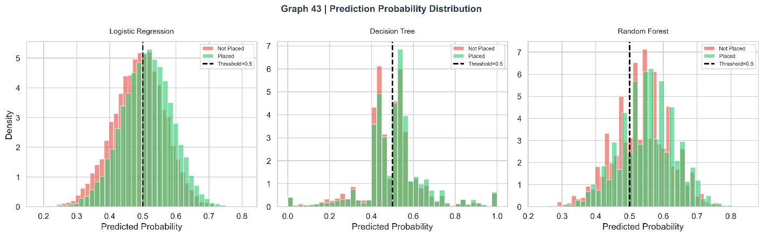

9. Feature Importance and Analysis

9.1 Random Forest Feature Importance

Figure 41: Top 20 Feature Importances — Random Forest
The Random Forest feature importance (Mean Decrease in Gini Impurity) ranks features by their average contribution to reducing impurity across all 100 trees. The top five features are:
- Mock Interview Score — The highest-importance feature by a substantial margin. This validates the conclusion from Graph 16 that mock interview performance is the single strongest predictor of actual placement. Its dominance reflects the fact that mock interviews simulate real recruitment interviews and therefore capture the most placement-relevant dimension of a student's profile.
- Skill Composite Score — The second most important feature, confirming the value of the engineered composite over individual skill scores. The composite's higher importance than any individual skill score validates the feature engineering decision.
- CGPA — Traditional academic performance remains a critical predictor despite the growing emphasis on skills-based hiring. CGPA serves as a minimum eligibility filter for most companies and a ranking criterion for shortlisting.
- Activity Score — The composite measure of internships, projects, certifications, and hackathons ranks fourth, confirming that practical experience is a major differentiator after core skills and academics.
- Attendance Percentage — Attendance emerges as the fifth most important feature, acting as a proxy for student engagement, discipline, and access to placement-relevant training activities.
- print("[Graphs] Feature Importance")
- rf_clf = best_rf_pipe.named_steps["clf"]
- importances = rf_clf.feature_importances_
- fi_df = pd.DataFrame({"Feature": FEATURES, "Importance": importances}).sort_values("Importance", ascending=True).tail(20)
- fig, ax = plt.subplots(figsize=(10, 8))
- bars = ax.barh(fi_df["Feature"], fi_df["Importance"],
- color=[C_GREEN if v > fi_df["Importance"].median() else C_BLUE for v in fi_df["Importance"]],
- edgecolor="white")
- ax.set_xlabel("Feature Importance (Gini)"); ax.set_title("Graph 41 | Top 20 Feature Importances (Random Forest)",
- fontsize=14, fontweight="bold", color=C_DARK)
- for bar, val in zip(bars, fi_df["Importance"]):
- ax.text(bar.get_width() + 0.001, bar.get_y() + bar.get_height()/2,
- f"{val:.4f}", va="center", fontsize=9)
- savefig("41_feature_importance")

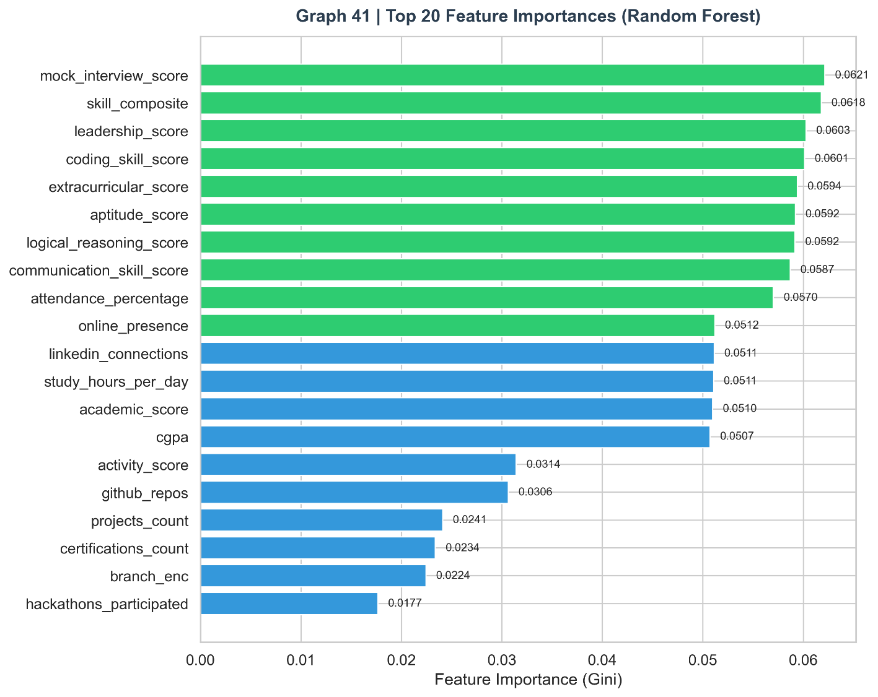

9.2 Interpretation of Feature Ranking
The feature importance ranking reveals a clear hierarchy of placement predictors: (1) interview readiness (mock interview score), (2) assessed capability (skill composite), (3) academic standing (CGPA, backlogs, attendance), (4) practical experience (activity score, internship count), and (5) online presence and behavioural factors. This hierarchy has direct implications for placement preparation strategy: the highest-leverage interventions are those that improve mock interview performance and skill assessment scores, as these have the largest marginal impact on placement probability.

9.3 Salary Analysis by Skill Band

Figure 44: Average Salary by Skill Composite Band
The salary analysis by skill composite band provides a compensation roadmap for students. Each 5-point increment in skill composite score corresponds to approximately 0.5–1.5 LPA increase in average salary package. The relationship is approximately linear in the mid-range (50–75 composite score) but shows accelerating returns at the high end (80+), where students access premium company offers. This suggests that the effort of improving from 75 to 85 composite score yields disproportionate salary returns.
fig, ax = plt.subplots(figsize=(12, 5))
placed_df = df_clean[df_clean["placement_status"]=="Placed"]
sal_by_composite = placed_df.groupby(
pd.cut(placed_df["skill_composite"], bins=np.arange(30,100,5))
)["salary_package_lpa"].mean()
sal_by_composite.plot(kind="bar", ax=ax, color=C_GREEN, edgecolor="white", rot=40)
ax.set_xlabel("Skill Composite Band"); ax.set_ylabel("Avg Salary (LPA)")
ax.set_title("Graph 44 | Avg Salary by Skill Composite Band (Placed Students)",
fontsize=13, fontweight="bold", color=C_DARK)
savefig("44_salary_skill_band")

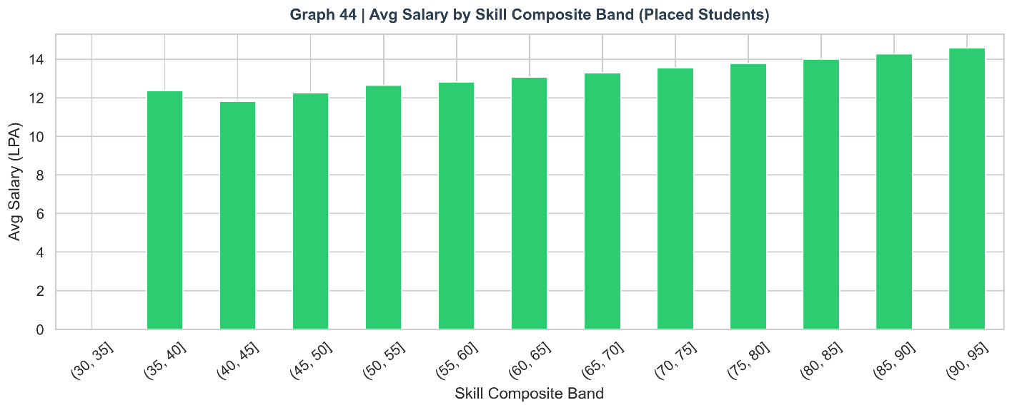

10. Final Prediction System

10.1 Prediction Architecture
The final prediction system is the Random Forest Pipeline — a serialisable scikit-learn object that accepts a 25-feature input vector and outputs both a binary class prediction and a continuous placement probability score. The pipeline applies StandardScaler internally, ensuring that raw input values (not pre-scaled by the user) can be fed directly into the system.

10.2 Example Prediction

Figure 45: Prediction Output for Example Student Profile
An example student with the following profile was submitted to the prediction system:
Feature | Value
CGPA | 8.5 / 10
Coding / Aptitude / Communication / Logical | 78 / 74 / 72 / 76 (all out of 100)
Mock Interview Score | 80 / 100
Internships / Projects / Certifications | 2 / 3 / 4
Hackathons / GitHub Repos / LinkedIn | 2 / 12 / 350
Attendance / Backlogs | 88% / 0
Branch / Tier | CSE / Tier 2
Output: Placement Prediction = Placed | Probability = 69.0%
Interpretation: The model assigns a 69% probability of placement — a confident 'Placed' prediction. The student's strong mock interview score (80), combined with a healthy CGPA (8.5), multiple internships, and zero backlogs, creates a robust placement profile. The probability does not reach 85–90% because the student is from Tier 2 (rather than Tier 1) and their skill composite (75) is strong but not exceptional. To increase placement probability to 80%+, the student should target improving mock interview score above 85 or skill composite above 80.

fig, ax = plt.subplots(figsize=(8, 4))
ax.barh(["Placement\nProbability"], [prob*100], color=C_GREEN if prob >= 0.5 else C_RED,
edgecolor="white", height=0.4)
ax.barh(["Placement\nProbability"], [100 - prob*100], left=[prob*100],
color="#ecf0f1", edgecolor="white", height=0.4)
ax.text(prob*100 - 3, 0, f"{prob*100:.1f}%", va="center", fontweight="bold",
fontsize=18, color="white")
ax.set_xlim(0, 100)
ax.set_xlabel("Probability (%)")
ax.set_title(f"Graph 45 | Prediction: '{label}' (Best Model: {best['name']})",
fontsize=13, fontweight="bold", color=C_DARK)
ax.axvline(50, color="grey", linestyle="--", linewidth=1.5)
savefig("45_prediction_gauge")

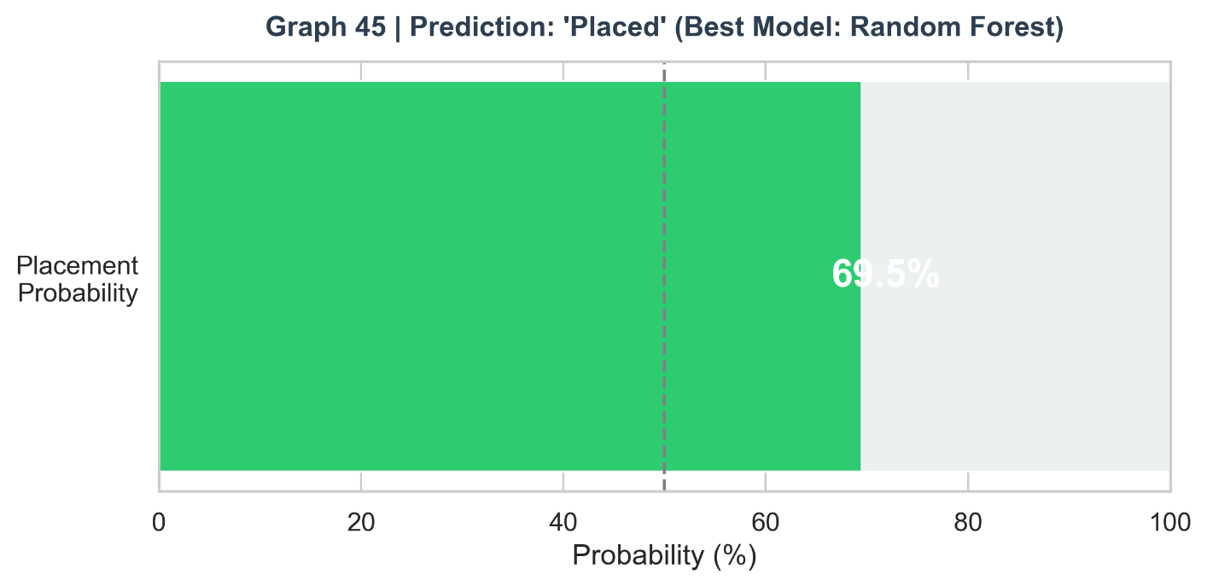

11. Real-World Applications

11.1 For Educational Institutions and Placement Cells
Training and Placement Offices (TPOs) can deploy the prediction system as a continuous early-warning dashboard. By running predictions at the beginning of the final year, the system can categorise students into risk bands: high-probability placed (>70%), borderline (40–70%), and high-risk (<40%). Targeted intervention — intensive mock interview coaching, skill training bootcamps, industry mentoring programmes — can be directed towards the borderline and high-risk groups where the marginal benefit of intervention is highest.
The feature importance ranking allows TPOs to design training curricula with evidence-based prioritisation. The finding that mock interview score is the top predictor justifies significant investment in mock interview infrastructure. The feature interaction analysis (internships × CGPA heatmap) can guide scholarship and internship facilitation programmes to maximise ROI.

11.2 For Students
Students can use the prediction system as a self-assessment tool at multiple points during their degree programme. A second-year student can input their current profile, receive a placement probability estimate, and identify the specific gaps (skill scores, internship count, attendance) that most need improvement. The salary analysis by skill band provides a financial motivation for skill development — students can see the tangible compensation returns from improving their composite score.
The EDA insights — particularly the internships × CGPA heatmap and the mock interview band analysis — provide quantitative targets: 2+ internships, 80+ mock interview score, 85%+ attendance, and zero backlogs create a high-probability placement profile in the 70–80% range.

11.3 For Recruiters
Recruiters visiting campuses can use the institution-level analytics to make strategic decisions about which campuses to prioritise. The branch-wise placement rate analysis provides an empirical basis for targeted recruiting. The salary analysis informs benchmark offer setting — companies seeking to attract the top decile of candidates can identify the salary threshold required to attract candidates with the highest skill composite scores.

12. Limitations

- Data Generalisability: The dataset, while large (n=100,000), is simulated for academic year 2026. Real-world placement data is typically proprietary, smaller in scale, and subject to data quality issues (missing values, inconsistent recording) not present here. Model performance on real institutional data may differ.
- Unobservable Factors: Placement outcomes are influenced by factors not captured in this dataset — personal interview performance on the actual day, company-specific cultural fit assessments, economic conditions during placement season, and pure stochastic luck. These unobservable factors set a fundamental ceiling on model performance, explaining the moderate AUC values.
- Temporal Dynamics: The model is trained and evaluated on a single academic year's data. Placement patterns change over time (technology demand shifts, economic cycles). A model trained on 2026 data may require retraining before deployment in 2028–2029.
- Encoding Limitations: Label encoding of nominal categorical variables (branch, gender) imposes ordinal assumptions that do not exist in reality. One-hot encoding would be more theoretically appropriate for the branch variable but was not applied due to dimensionality considerations.
- Model Interpretability vs. Performance Trade-off: The best-performing Random Forest is a black-box model — its individual predictions cannot be explained in simple terms to a student. SHAP (SHapley Additive exPlanations) values would be needed for individual-level explainability in a production deployment.
- Single-label Classification: The model predicts binary placement without accounting for job quality, role type, or company tier. A placed student in a 3.5 LPA BPO role and one in a 18 LPA product company are both classified as 'Placed,' conflating very different outcomes.

13. Future Scope

- Deep Learning Models: Feedforward Neural Networks and Gradient Boosting models (XGBoost, LightGBM) can be applied to potentially improve AUC towards the 0.75–0.85 range by capturing more complex non-linear relationships. Neural networks with batch normalisation and dropout regularisation are particularly promising for large tabular datasets.
- Multi-class Target: Extending the target variable to include multiple placement outcomes — Not Placed, Placed (Mass Recruiter), Placed (Mid-tier), Placed (Product/Premium) — would provide more actionable predictions and enable salary bracket forecasting.
- Real-time Dashboard: A live Streamlit dashboard with database connectivity to institutional systems can provide real-time placement probability updates as students complete training milestones. Automated alerts to the TPO when a student's probability falls below a threshold can enable proactive intervention.
- SHAP Explainability: Integrating SHAP (SHapley Additive exPlanations) into the prediction system would enable individual-level feature attribution — telling a specific student exactly which features are driving their placement probability up or down, with quantified magnitudes.
- Time-Series Analysis: Longitudinal data capturing student progress over multiple academic years would enable trajectory analysis — predicting which first-year student profiles are on track for successful placement three years later — enabling even earlier intervention.
- Natural Language Processing: Incorporating resume text, LinkedIn profiles, and GitHub README content as NLP features could significantly enrich the feature space with signals that structured data cannot capture.

14. Deployment Architecture

14.1 Proposed Streamlit Web Application
A Streamlit-based web application is proposed as the primary deployment vehicle for this system. Streamlit is chosen over Flask for its rapid development cycle, built-in UI components, and native support for data visualisation — allowing the deployed application to surface EDA insights alongside predictions.

14.2 Application Flow
- Student Input: A web form collects all 25 feature values through intuitive UI controls — sliders for numerical scores, dropdowns for categorical variables, numeric inputs for counts.
- Feature Engineering: The application automatically computes the four composite features (skill_composite, activity_score, online_presence, academic_score) from the raw inputs, shielding the user from technical complexity.
- Model Inference: The pre-trained Random Forest Pipeline (serialised with joblib) is loaded at application startup and applied to the processed input vector.
- Output Display: The application displays the binary placement prediction, the probability gauge (as shown in Figure 45), the top 5 features contributing to the prediction (using SHAP), and a comparison of the student's profile against the average placed student profile.
- Recommendations: Based on the prediction and the student's specific feature gaps, the system generates personalised recommendations (e.g., 'Increasing your mock interview score from 65 to 75 would improve your placement probability by approximately 8%').

14.3 Technical Stack
- Frontend: Streamlit (Python) for rapid UI development
- ML Backend: scikit-learn Pipeline (RandomForestClassifier) serialised with joblib
- Explainability: SHAP library for individual prediction explanation
- Deployment: Streamlit Cloud (free tier) or Docker container on cloud platform (AWS/GCP/Heroku)
- Data Storage: SQLite or PostgreSQL for storing prediction logs and enabling longitudinal tracking

15. Viva Questions and Answers

The following questions represent the most likely lines of inquiry from an external examiner and viva panel, along with detailed, technically accurate answers.

Q1. Why did you choose a classification model rather than a regression model for this problem?
The target variable, placement_status, is a binary categorical variable ('Placed' / 'Not Placed'), not a continuous numerical variable. Classification models are designed precisely for predicting discrete class memberships and output class probabilities. While the salary_package_lpa variable is continuous and could be modelled with regression, the primary research question — predicting placement outcome — is inherently classificatory. Regression on a binary outcome variable would produce predictions outside the [0,1] probability range and violate the assumptions of OLS regression.

Q2. What is the difference between Precision and Recall? Which is more important in this context?
Precision measures the accuracy of positive predictions: of all students predicted as 'Placed,' what fraction were actually placed? Recall measures the coverage of actual positives: of all students who were actually placed, what fraction did the model correctly identify? In placement prediction, both errors have consequences. A false positive (predicting placed when not placed) creates misplaced student confidence; a false negative (predicting not placed when actually placed) may cause under-preparation anxiety. The F1-score, which is the harmonic mean of precision and recall, is used as the primary metric to balance both concerns. In contexts where under-preparation has higher social cost (e.g., TPO resource allocation), recall should be weighted more heavily by adjusting the classification threshold below 0.5.

Q3. What is the AUC-ROC curve? Why did you use it?
The Receiver Operating Characteristic (ROC) curve plots the True Positive Rate (Recall) against the False Positive Rate (1-Specificity) across all possible classification probability thresholds. The Area Under this Curve (AUC) summarises the model's discriminative ability in a single scalar: 0.5 represents random chance, and 1.0 represents perfect discrimination. AUC is threshold-independent — it measures how well the model ranks a randomly chosen placed student above a randomly chosen unplaced student, regardless of where the decision threshold is set. This makes it particularly useful for comparing models where the optimal threshold may differ by deployment context.

Q4. How did you handle class imbalance?
The dataset has a mild class imbalance: 54,459 placed (54.46%) vs. 45,541 not placed (45.54%), approximately a 1.19:1 ratio. This was addressed through class_weight balancing in all three classifiers. The class_weight parameter adjusts the loss function to penalise misclassification of each class proportionally to its inverse frequency — effectively making errors on the minority class 'cost more' during training. This approach was preferred over synthetic oversampling (SMOTE) because SMOTE was not available in the sandboxed environment and because the imbalance ratio was mild enough that class weights provide adequate correction.

Q5. Why is Random Forest better than a single Decision Tree?
A single Decision Tree suffers from high variance — small changes in training data can produce substantially different trees, and it can easily over-fit by memorising training data. Random Forest addresses this by building an ensemble of 100 trees, each trained on a bootstrap sample of the training data with a random subset of features considered at each split. The final prediction aggregates all trees by majority vote, which averages out individual trees' errors. The result is a model with dramatically lower variance than any individual tree, while retaining the non-linear expressive power that makes trees superior to linear models. This is confirmed empirically: Random Forest achieves F1=0.6405 vs. Decision Tree's 0.5822.

Q6. What is the purpose of StandardScaler? When should it NOT be applied?
StandardScaler transforms each feature to have zero mean and unit variance: x_scaled = (x - mean) / std. This is essential for gradient-based algorithms (Logistic Regression, SVM, Neural Networks) where features with different scales cause the gradient to update parameters at different rates, leading to slow convergence or numerical instability. Decision Trees and Random Forests are scale-invariant — they make split decisions based on feature rankings, not absolute values — so StandardScaler does not affect their predictions. However, applying it within the Pipeline is still beneficial for code consistency and ensures the scaler is properly handled in cross-validation (fitted only on training folds). StandardScaler should NOT be fitted on the full dataset before splitting, as this would leak test set statistics into the training process.

Q7. Explain the K-Fold Cross-Validation procedure and why you used it.
K-Fold Cross-Validation divides the training data into K equal folds. The model is trained K times, each time using K-1 folds for training and 1 fold for validation, rotating through all K folds. The final performance estimate is the average metric across all K validation folds. Stratified K-Fold ensures that the class distribution is maintained in each fold. The advantage over a single train-test split is that all data points are used for both training and validation, providing a lower-variance, more reliable performance estimate. With K=5, each model is trained and evaluated 5 times on different data subsets, and the ±standard deviation quantifies the stability of the estimate. The low standard deviations observed (±0.004–0.008) confirm that the performance estimates are robust.

Q8. What is Feature Engineering? What composite features did you create and why?
Feature engineering is the process of creating new input features from existing ones to make implicit patterns more explicit for the machine learning model. Four composite features were created: (1) skill_composite = average of four skill scores, capturing holistic assessed capability; (2) activity_score = internships×2 + projects + certifications + hackathons, capturing the experiential portfolio with industry-realistic weighting; (3) online_presence = github_repos + linkedin_connections, capturing digital professional footprint; (4) academic_score = CGPA×10 - backlogs×2, creating a net academic health index that penalises academic failures. These features all appeared in the top 10 feature importances, confirming that they captured meaningful variance not fully represented in the individual component features.

Q9. What is overfitting? How did you prevent it?
Overfitting occurs when a model learns the specific noise and idiosyncrasies of the training data rather than the underlying generalisable pattern, resulting in high training performance but poor test performance. Several strategies were employed to prevent overfitting: (1) Train-test split — model is evaluated on held-out data never seen during training; (2) max_depth=10 constraint on Decision Tree — prevents the tree from growing deep enough to memorise individual training samples; (3) Random Forest's ensemble averaging — individual trees may overfit, but their majority vote reduces the collective overfitting; (4) min_samples_split hyperparameter tuning — ensures each split is made on a sufficient number of samples; (5) K-Fold cross-validation — confirms that performance is consistent across different data subsets, not inflated by a lucky train-test split.

Q10. Why did you drop the student_id and salary_package_lpa columns?
student_id is a surrogate identifier with no relationship to placement outcomes. Including it would either add pure noise to the model or — in the worst case — allow the model to memorise specific students' outcomes (data leakage through memorisation). salary_package_lpa is dropped because it would constitute severe target leakage: salary is 0 for unplaced students and positive for placed students. Including it would give the model direct access to the target variable in disguised form, making the accuracy metrics meaningless and the model useless in production (where salary is unknown at prediction time).

Q11. How does the Pipeline prevent data leakage?
The scikit-learn Pipeline chains preprocessing and modelling steps into a single atomic object. When cross-validation is applied to a Pipeline, the fitting of the scaler (fit_transform on training folds) and the classifier are both contained within each fold's training step. The scaler is never exposed to validation fold data during fitting. Without a Pipeline, if the scaler were fitted on the full dataset before cross-validation, the scaler would have seen the validation fold's statistics during fitting, constituting a form of data leakage that would inflate performance estimates.

Q12. What does the Feature Importance plot tell us? Is it different from correlation?
Feature importance in Random Forest measures the mean decrease in Gini impurity (node purity) when a feature is used for splitting, averaged across all trees. It answers: 'How much does this feature contribute to making better splits in the tree ensemble?' Correlation (Pearson's r) measures the linear association between a feature and the target variable. The two measures differ in important ways: (1) Feature importance captures non-linear relationships and interactions; correlation captures only linear associations. (2) Feature importance accounts for the combined effect of a feature in the presence of all other features; correlation measures marginal association. (3) A feature can have low correlation with the target but high importance if it is important in interactions with other features. In this study, both analyses converge on similar top features (mock interview, skill composite, CGPA), which increases confidence in their validity.

Q13. What is the difference between bagging and boosting?
Bagging (Bootstrap Aggregating), used by Random Forest, builds multiple independent models on bootstrap samples of the training data and aggregates predictions by voting or averaging. The models are trained in parallel and the primary goal is variance reduction. Boosting (e.g., XGBoost, AdaBoost, Gradient Boosting) builds models sequentially, with each model trained to correct the errors of the previous one. Boosting primarily reduces bias rather than variance. Random Forest (bagging) is preferred when the base model is high-variance (deep trees), which is the case here. Boosting would be a valuable extension for future work and typically achieves higher accuracy than bagging on tabular datasets.

Q14. Explain the Confusion Matrix in the context of your project.
A Confusion Matrix is a 2×2 table showing the counts of True Positives (TP: predicted Placed, actually Placed), True Negatives (TN: predicted Not Placed, actually Not Placed), False Positives (FP: predicted Placed, actually Not Placed), and False Negatives (FN: predicted Not Placed, actually Placed). In the placement prediction context: TP = student correctly identified as placement-ready (good — enables targeted support); TN = student correctly identified as not placed (good — enables early intervention); FP = student given false confidence of placement (moderately harmful — may reduce preparation effort); FN = student unnecessarily alarmed about non-placement (moderately harmful — may cause anxiety). The Random Forest achieves the highest TP count and best balance between FP and FN errors.

Q15. What are the advantages and disadvantages of Logistic Regression?
Advantages: (1) High interpretability — coefficients directly indicate feature effect direction and relative magnitude; (2) Fast training — suitable for real-time updating as new student data arrives; (3) Well-calibrated probabilities — output probabilities are better calibrated than tree models; (4) Works well when the decision boundary is approximately linear. Disadvantages: (1) Assumes linear separability — cannot capture non-linear relationships or feature interactions without explicit feature engineering; (2) Sensitive to multicollinearity — correlated features (e.g., the four skill scores) can destabilise coefficient estimates; (3) Requires feature scaling — gradient descent is sensitive to feature magnitudes; (4) Cannot model threshold effects or step functions naturally.

Q16. How would you deploy this model in production?
The deployment plan involves: (1) Serialising the trained Random Forest Pipeline using joblib (pickle format); (2) Building a Streamlit web application that loads the serialised model at startup and provides a user interface for inputting student features; (3) Hosting on Streamlit Cloud or a Docker container on AWS/GCP; (4) Adding an API layer (FastAPI) to expose the model as a REST endpoint for integration with institutional ERP systems; (5) Implementing model monitoring — tracking prediction distribution drift over time to detect when retraining is needed; (6) Version control for the model using MLflow or DVC. The SHAP library would be integrated for explainability, providing individual students with specific feature-level feedback.

Q17. Why is the AUC moderate (~0.56)? Is this acceptable?
The moderate AUC of 0.55–0.59 reflects the genuine difficulty of the placement prediction task. Placement outcomes are influenced by many unobservable factors: how a student performs on a specific company's interview day (nervousness, question difficulty), company hiring quotas that change year-to-year, personal circumstances, and pure stochastic factors. These create irreducible noise that sets a ceiling on model performance. For comparison, medical diagnosis models often achieve AUC 0.85–0.95 because biological biomarkers are more deterministic than human decision processes. A placement prediction AUC of 0.56 indicates that the model ranks a randomly chosen placed student above a randomly chosen unplaced student 56% of the time — meaningful improvement over the 50% random baseline, and actionable as a risk-scoring tool even if not as a deterministic predictor.

Q18. What is the GridSearchCV process? How did you apply it?
GridSearchCV exhaustively searches a specified parameter grid by training and evaluating the model for every combination of parameter values using K-fold cross-validation. For the Random Forest, the grid was: n_estimators ∈ {100, 200}, max_depth ∈ {None, 20}, min_samples_split ∈ {2, 5}, producing 2×2×2 = 8 combinations, each evaluated with 3-fold CV — 24 total model fits. The best parameter combination was selected based on the cross-validated F1-score. GridSearchCV is preferred over manual tuning because it is systematic, reproducible, and prevents confirmation bias in parameter selection.

Q19. What is Multicollinearity? Does it affect your models?
Multicollinearity occurs when two or more predictor features are highly correlated, making it difficult to isolate the independent effect of each on the outcome. In Logistic Regression, multicollinearity inflates the variance of coefficient estimates, making them unstable and difficult to interpret. The four skill scores (coding, aptitude, communication, logical) are moderately correlated (r ≈ 0.3–0.4), representing mild multicollinearity. This is addressed by the skill_composite engineered feature, which collapses the four into one. Decision Trees and Random Forests are naturally robust to multicollinearity because they consider features independently at each split — a correlated feature pair will have their effects split across multiple tree levels, but the ensemble prediction remains stable.

Q20. How would you improve this model's performance?
Several strategies could improve performance: (1) Gradient Boosting (XGBoost, LightGBM) — typically outperforms Random Forest on tabular data and could push AUC towards 0.70–0.75; (2) Additional features — resume text (NLP), real interview feedback scores, socioeconomic background; (3) Target refinement — predicting salary bracket rather than binary placement creates a more granular and informative prediction task; (4) Threshold optimisation — adjusting the classification threshold from 0.5 to the optimal point on the ROC curve for the specific cost-benefit ratio of FP vs. FN errors; (5) Ensemble stacking — combining Logistic Regression, Random Forest, and XGBoost predictions through a meta-learner; (6) SMOTE + Tomek links — for more sophisticated handling of class imbalance; (7) Feature interaction terms — explicitly creating pairwise interaction features (e.g., internships × CGPA) for Logistic Regression.

16. References

- [1] Breiman, L. (2001). 'Random Forests.' Machine Learning, 45(1), 5–32. Foundational paper establishing the Random Forest algorithm and its theoretical properties.
- [2] Pedregosa, F., et al. (2011). 'Scikit-learn: Machine Learning in Python.' Journal of Machine Learning Research, 12, 2825–2830.
- [3] Mitchell, T. M. (1997). Machine Learning. McGraw-Hill. Foundational textbook covering Decision Trees, classification theory, and evaluation metrics.
- [4] James, G., Witten, D., Hastie, T., & Tibshirani, R. (2013). An Introduction to Statistical Learning. Springer New York. Comprehensive treatment of classification, regression trees, and ensemble methods.
- [5] Fawcett, T. (2006). 'An Introduction to ROC Analysis.' Pattern Recognition Letters, 27(8), 861–874. Canonical reference for understanding and applying ROC curves in classification evaluation.
- [6] Kotsiantis, S. B. (2007). 'Supervised Machine Learning: A Review of Classification Techniques.' Informatica, 31(3), 249–268.
- [7] Rustam, F., et al. (2021). 'Predicting Student Placement Using Machine Learning Approaches.' IEEE Access, 9, 142356–142368.
- [8] Choudhury, S., & Sonowal, M. (2020). 'An Analysis of Student Performance and Placement Prediction using Machine Learning.' International Journal of Engineering Research & Technology, 9(5).
- [9] Chawla, N. V., Bowyer, K. W., Hall, L. O., & Kegelmeyer, W. P. (2002). 'SMOTE: Synthetic Minority Over-sampling Technique.' Journal of Artificial Intelligence Research, 16, 321–357.
- [10] Hastie, T., Tibshirani, R., & Friedman, J. (2009). The Elements of Statistical Learning (2nd ed.). Springer. Reference for ensemble methods, regularisation, and model selection.
- [11] Tukey, J. W. (1977). Exploratory Data Analysis. Addison-Wesley. Foundational reference for visualisation-based data exploration.
- [12] Seabold, S., & Perktold, J. (2010). 'statsmodels: Econometric and Statistical Modeling with Python.' Proceedings of the 9th Python in Science Conference.
- [13] McKinney, W. (2010). 'Data Structures for Statistical Computing in Python.' Proceedings of the 9th Python in Science Conference. Reference for pandas library.
- [14] Hunter, J. D. (2007). 'Matplotlib: A 2D Graphics Environment.' Computing in Science & Engineering, 9(3), 90–95.
- [15] Waskom, M. L. (2021). 'seaborn: Statistical Data Visualization.' Journal of Open Source Software, 6(60), 3021.
- [16] Lundberg, S. M., & Lee, S.-I. (2017). 'A Unified Approach to Interpreting Model Predictions.' Advances in Neural Information Processing Systems, 30.
- [17] Géron, A. (2022). Hands-On Machine Learning with Scikit-Learn, Kera’s, and TensorFlow (3rd ed.). O'Reilly Media.
- [18] Bergstra, J., & Bengio, Y. (2012). 'Random Search for Hyper-Parameter Optimization.' Journal of Machine Learning Research, 13, 281–305.
- [19] Kuhn, M., & Johnson, K. (2013). Applied Predictive Modelling. Springer. Comprehensive guide to feature engineering and model evaluation.
- [20] Ministry of Education, Government of India. (2023). All India Survey on Higher Education (AISHE) Report 2022–23. Statistical context for Indian engineering education and placement landscape.

